### Smart Solutions for Railways based on IoT

Industrial/Practical Training Report

Submitted to the

Department of Electronics and Communication Engineering

**SESHADRIRAO GUDLAVALLERU ENGINEERING COLLEGE**

In partial fulfillment of the requirements,

for the award of the Degree of

**Bachelor of Technology**

in

**Electronics and Communication Engineering**

By

**Kodavalla Monalika**

**(20485A0408)**

**Department of Electronics and Communication Engineering**

**SESHADRIRAOGUDLAVALLERU ENGINEERING COLLEGE**

SESHADRI RAO KNOWLEDGE VILLAGE

GUDLAVALLERU – 521356

ANDHRA PRADESH

**2022-2023**



**DECLARATION**

I Kodavalla Monalika hereby declare that this industrial training report is the record of authentic work carried out by me during the period 26.03.2022 to 30.07.2022 in **Smart Bridge Pvt. Ltd** under the supervision of my training. In charge Nikhil Gurram Smart Bridge Pvt. Ltd.

Signature:

Name of the student: K. Monalika

**ACKNOWLEDGEMENT**

I am very glad to express my deep indebtedness to all the employees of Smart Bridge Pvt. Ltd. Without their support and guidance, it would not have been possible for this training to have materialized and taken a concrete shape. I extend my deep gratitude to my training mentor – Sandeep Doodigani, Divya Nemuri, Gnaneswar Bandari, Ancy Jenifer J, who supported us all the time. I owe my personal thanks to our HOD **Dr. Y. Rama Krishna** and our industrial training coordinator **Mr. N. Samba Murthy** for undergoing training at a reputed company like Smart Bridge Pvt. Ltd.

We would like to take this opportunity to express our profound sense of gratitude to our beloved Principal **Dr. G. V. S. N. R. V. Prasad**, for providing us all the required facilities. We express our thanks to Teaching and Non-Teaching staff of electronics and communication engineering department who helped us directly or indirectly in completion of our internship.

K. Monalika

(20485A0408)

**CONTENTS**

**TITLE**

LIST OF FIGURES

LIST OF TABLES

ABSTRACT

**CHAPTER 01:**

**1.0** Introductions to IoT

* 1. Introduction to open Hardware Platforms and Tinker cad Circuits
  2. Arduino – Tinker cad
  3. Introduction to Python and Python Basics

**1.3.0** Python Introduction

* + 1. Python Basics
    2. Conditional Statements and Functional basics
    3. Data Variables and Basic Variables
    4. Lists, Tuples and Dictionaries
    5. Functions and Modules
    6. Files IO and Python Inbuild Libraries
    7. Python OOPS Concepts
    8. Networking – Socket Programming

**CHAPTER 02:**

**2.0** IoT Communication Technologies and Protocols

**2.0.0** Communication Technologies

**2.0.1** Communication Protocol

**2.1** IBM Cloud Platforms

**2.1.0** Introduction to IBM Cloud and its Architecture

**2.1.1** IBM IoT Device creation and connecting Internal Simulator

**2.1.2** Connecting to IBM IoT Platform and sending sensor data using python code

**CHAPTER 03:**

**3.0** IBM Cloud Services

**3.0.0** IBM Cloudant

**3.0.1** IBM Object Storage

**3.1** Node red

**3.1.0** Retrieving Data from IBM IoT Platform

**3.1.1** Sending Command to the Device

**3.2** Watson Assistant using python code

**CHAPTER 04:**

**4.0** MIT App Inventor

**4.1** Applications

**4.1.0:** Smart tracking (Geofence)

**4.2** IBM cloud functions

**CHAPTER 05:**

**5.1** Purpose of the project

**5.2** Proposed solution

**5.3** Block Diagram

**5.4** Hardware/Software Designing

**5.5** Project Code

**5.6** Advantages and disadvantages

**5.7** Applications

**5.8** Results

**CHAPTER 06:**

**6.0** Conclusion

**ABSTRACT**

We have done our internship at **Smart Bridge** in Virtual mode. There are different areas in Electronics and communication Engineering and we have chosen Internet of Things (IoT), newly emerged technology with a group of students.

In our internship, we have studied various Virtual Platforms like Tinker cad, IBM Cloud Platform and Python Programming. We have learnt how to use Virtual Environment to perform the Hardware Projects using the Tinker cad and ARDUINO. We have done the Smart solutions for railways based on IoT.

As an application of these, we have done a project comprised of a Team of 5 members. Our Project name is IoT Analytics in Smart solutions for railway system. With the help of Smart Internz Platform we started our project with the knowledge we have gained in this Internship. We successfully completed our Project using the Python Programming and IBM Cloud Services.

In this way the knowledge we have gained in the Smart Bridge company is useful to us.

**Key words**

* IoT
* Arduino
* Cloud
* Virtual.

**LIST OF FIGURES**

**Figure No Figure Name Page No**

1. Internet of Things (IoT) Application in different Sectors 7

2. IoT Architecture 8

3. IoT Technology Stack 8

4. Arduino UNO Board 9

5. Experiments in Tinker cad 10

6. Addition, Subtraction, Multiplication, Division using Python 12

7. String, Hello World in Python Programming 12

8. Various Operations using Python. 13

9. Socket Programming Code- Creating Socket & 20

Waiting for Connection

10. Command Prompt Output-Client Data 21

11. Output from Python Compiler - From Server. 21

12. IBM IoT Platform Architecture 28

13. IBM account Creation &IoT Service 29-31

14 . Python Programming to send data 32

15. Cloudant in catalog page 33

16. Cloudant database creating page 34

17. Cloudant launch dashboard 34

18. Creating database 35

19. Editor page 35

20. Data is created in j.son format 36

21. Object storage 36

22. Creating object storage 37

23. Creating buckets 37

24. Data is stored 38

25. Node red flow diagrams 39

26. IOT simulator 40

27. Sending command to device 40 28. Receiving data from web 40

29. Watson Assistant AI platform 41

30. Watson assistant preview 42

31. Creating a MIT app 43

32. Node red code for smart tracking with geofence 44

33. Smart tracking with geofence 45

34. Block diagram of smart railway system based on IoT 47

35. Python code output 51

36. Node red flow 51-52

37. Node red flow dashboard 53-55

38. MIT app UI 56-57

**LIST OF TABLES**

**S. No Table Name Page No**

1. Arduino UNO Feature 10
2. Mode’s description in Opening files in python 16
3. Python File Methods Description 18
4. Difference between GET and POST 25
5. HTTP Status Codes 26
6. 2xx Successful 26
7. 4xx Client Error 26

**CHAPTER 01**

**1.0 Introduction to IoT:**

What is IoT?

* Connecting everyday things embedded with electronics, software and sensors to the internet enabling them to collect and exchange data.

Benefits of IoT:

1. Improved Performance
2. Reduced Cost
3. Improved Data Collection
4. Improved Customer Engagement
5. New Revenue Streams

Applications:

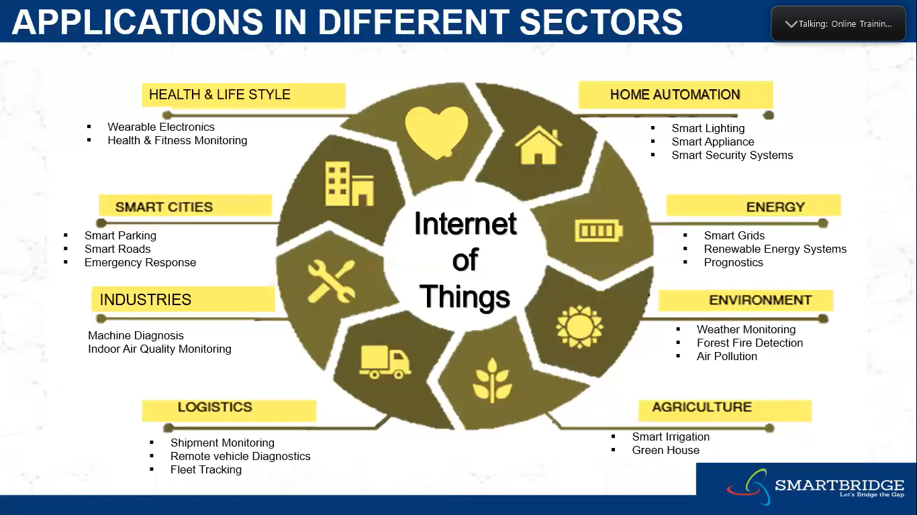

**Fig 1:** Internet of Things (IoT) Application in different Sectors

What is IoT Architecture?

IoT architecture is the system of numerous elements: sensors, protocols, actuators, cloud services, and layers. Given its complexity, there exist 4 stages of IoT architecture. Such a number is chosen to steadily include these various types of components into a sophisticated and unified network.

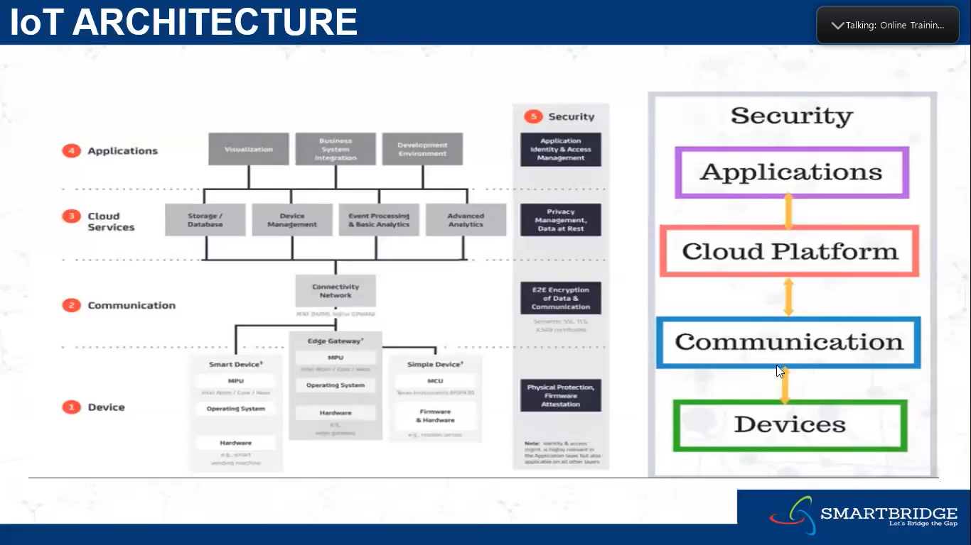

**Fig 2:** IoT Architecture

IoT Technology Stack:

* **The IoT technology stack is nothing else than a range of technologies, standards and applications, which lead from the simple connection of objects to the Internet to the easiest and most complex applications that use these connected things, the data they gather and communicate and the different steps needed to power these applications.**

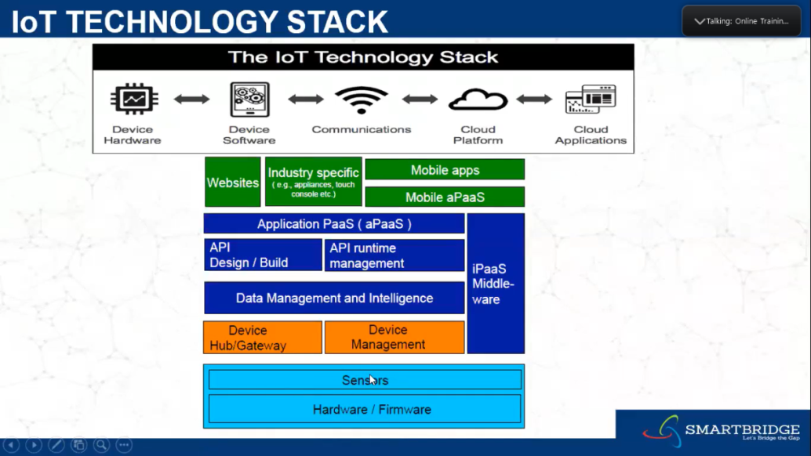 **Fig 3:** IoT Technology Stack

* 1. **Introduction to open Hardware Platforms and Tinker cad Circuits:**

**What is Arduino?**

* + Arduino is an open-source platform used for building electronics projects.
  + Easy tool for fast prototyping.
  + Consists of both a physical programmable circuit board and a piece of software.

**Why Arduino?**

* Open-Source Platform
* Inexpensive
* Does not need a separate piece of hardware
* Arduino IDE uses a simplifies version of C++
* Cross-Platform
* Provides a standard form factor.

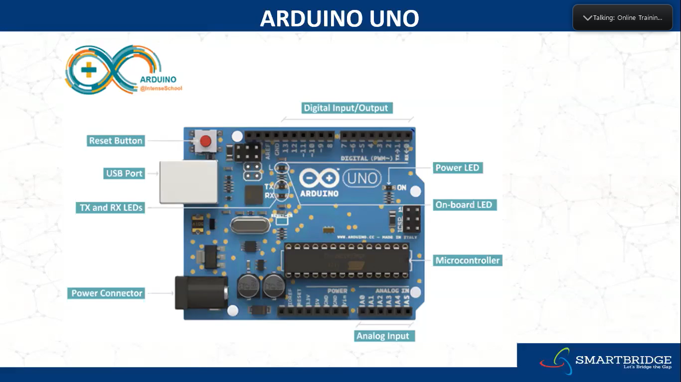

**Fig 4:** Arduino UNO Board

**Arduino UNO Features:**

|  |  |
| --- | --- |
| Operating Voltage | 5V and 3.3V |
| Input Voltage (recommended) | 7-12 V |
| Input Voltage (limits) | 6-20 V |
| Digital I/O Pins | 14 (6 provide PWM output) |
| Analog Input Pins | 6 |
| DC Current per I/O Pin | 40 mA |
| DC Current for 3.3 V Pin | 50 mA |
| Flash Memory | 32 KB (ATmega328) |
| SRAM | 2 KB (ATmega328) |
| EEROM | 1 KB (ATmega328) |
| Clock Speed | 16 MHz |
| Microcontroller | ATmega328 |

**Table 1:** Arduino UNO Feature

* 1. **Arduino – Tinker cad:**

Use of Thinker Cad

* Tinker cad is a free, easy-to-use app for 3D design, electronics, and coding. It's used by teachers, kids, hobbyists, and designers to imagine, design, and make anything!

List of the Experiments done with Thinker cad:

* Buzz
* Smart Door
* Blinker with TMP
* PIR Sensor
* LED Blink
* Piezo
* Ultrasonic Sensor
* Temp Sensor
* Servo Motor
* LED with Potentiometer
* Digital Input and Output

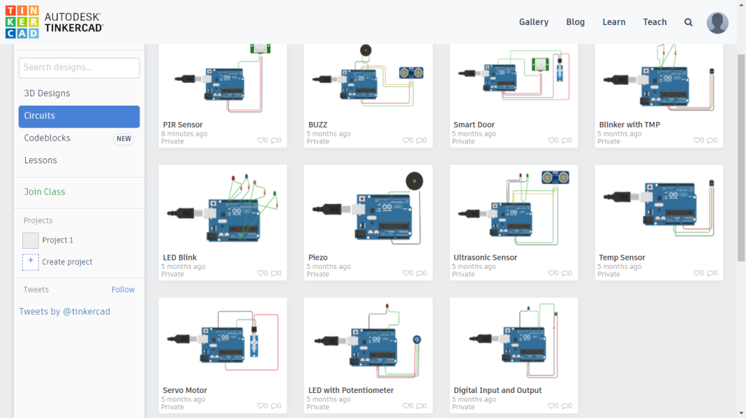

**Fig 5:** Experiments in Tinker cad

* 1. **Introduction to Python and Python Basics:**

**1.3.0 Python Introduction:**

**What is Python?**

* General Purpose
* Interpreted
* High Level
* Dynamically Typed

**General Purpose:**

Python language is a general-purpose language because it can be applicable to all domains, such type of languages is generic and not specialized.

**Interpreted:**

An Interpreted language will read the Raw code without being explicitly compiled before execution.

**High Level:**

Python allows programmers to express their logic in a form which is very close to human language. This helps in many computing aspects like memory management and data management.

**Dynamically Typed:**

Python identifies the type of variables on the basis of what kind of data you have assigned to the variable.

Why Choose Python?

* Readily available and open source
* Huge Libraries
* Easy to understand and learn
* Big developer Communities
* Fewer code lines and larger Functionalities.

**1.3.1 Python Basics:**

Here is a list of the Python keywords. Enter any keyword to get more help.

False class from or

None continue global pass

True def if raise

and del import return

aselif in try

assert else is while

async except lambda with

await finally nonlocal yield

break for not

Basic Python Programming: -

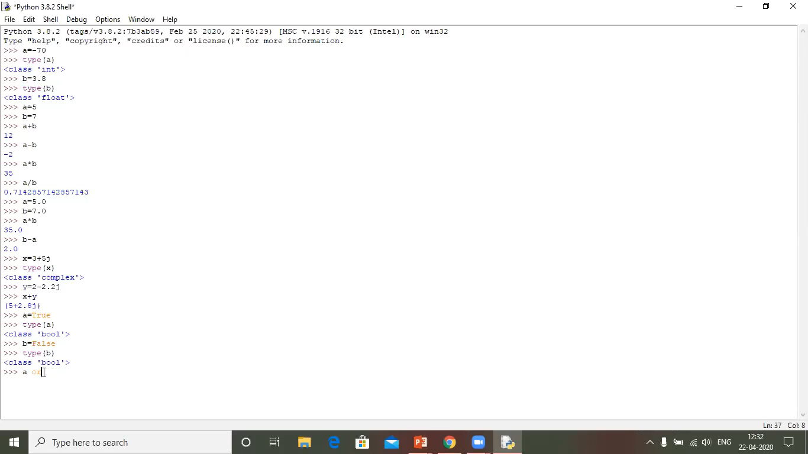

**Fig 6:** Addition, Subtraction, Multiplication, Division using Python.

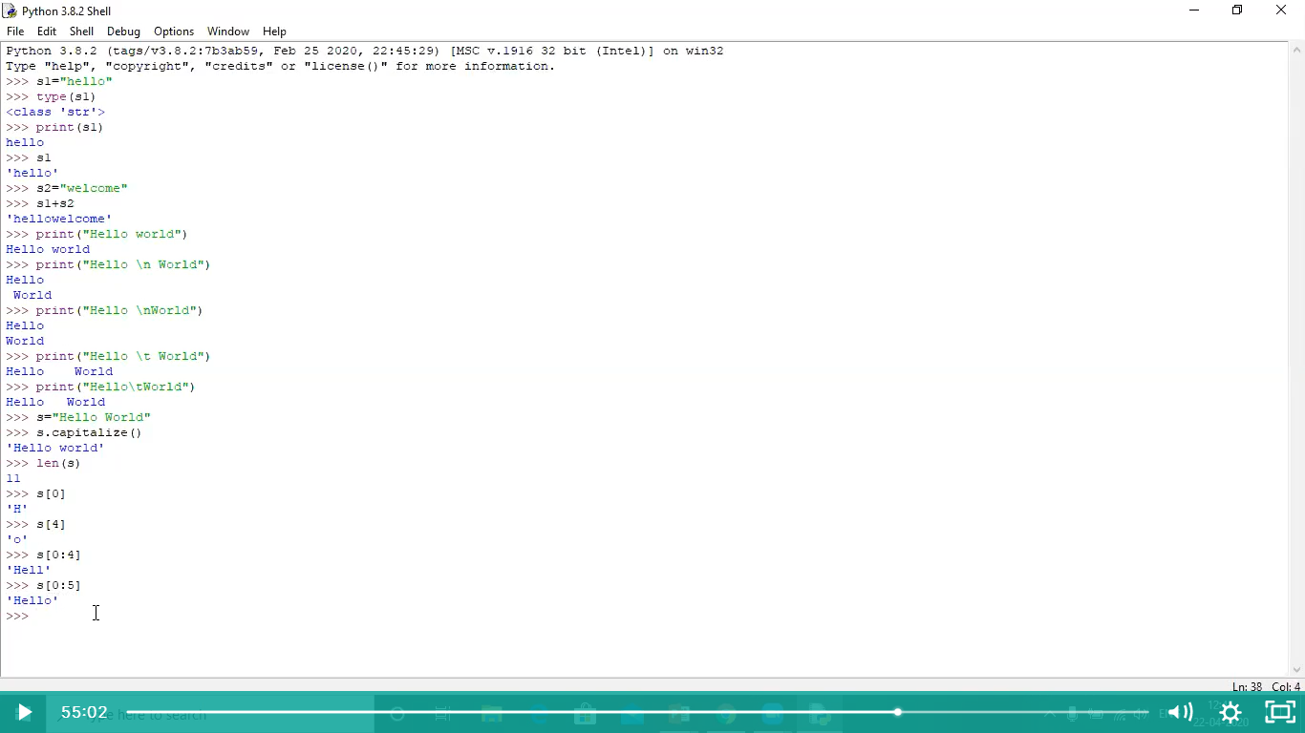

**Fig 7:** String, Hello World in Python Programming.

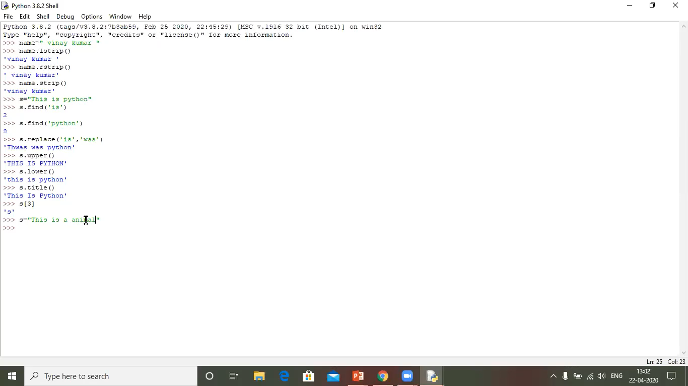

**Fig 8:** Various Operations using Python.

**1.3.2 Conditional Statements and Functional basics:**

Conditional Statements:

A conditional statement in Python is handled by if statements and we saw various other ways we can use conditional statements like if and else over here.

* "if condition" – It is used when you need to print out the result when one of the conditions is true or false.
* "else condition"- it is used when you want to print out the statement when your one condition fails to meet the requirement
* "elif condition" – It is used when you have third possibility as the outcome. You can use multiple elif conditions to check for 4th,5th,6th possibilities in your code
* We can use minimal code to execute conditional statements by declaring all condition in single statement to run the code
* If Statement can be nested.

Syntax:

if expression

Statement

else expression

Statement

**Basic Functions:**

What is function in Python?

* A function is a group of related statements that performs a specific task.
* Functions help break our program into smaller and modular chunks. As our program grows larger and larger, functions make it more organized and manageable.
* It avoids repetition and makes the code reusable.

**Syntax:**

Def function_name(parameters):

“”’docstring”””

Statements(s)

Function definition that consists of the following components:

1. Keyword **def** that marks the start of the function header.
2. A function name to uniquely identify the function. Function naming follows the same rules of writing identifiers in python.
3. Parameters (arguments) through which we pass values to a function. They are optional.
4. A colon (:) to mark the end of the function header.
5. Optional documentation string (docstring) to describe what the function does.
6. One or more valid python statements that make up the function body. Statements must have the same indentation level (usually 4 spaces).
7. An optional **return** statement to return a value from the function.

**Types of Functions:**

1. Built-in functions - Functions that are built into Python.
2. User-defined functions- Functions defined by the users themselves.

**1.3.3 Data Variables and Basic Variables:**

Data Types in Python:

Every value in Python has a data type. Since everything is an object in Python programming, data types area actually classes and variables are instance (object) of these classes.

There are various data types in Python. Some of the important types are listed below.

1. **Python Numbers:**

* Integers, floating point numbers and complex numbers fall under Python numbers category. They are defined as int, float, and complex classes in Python.
* We can use the **type ()** function to know which class a variable or a value belongs to. Similarly, the **isinstance ()** function is used to check of an object belongs to a particular class.

1. **Python Strings:**
   * + String is sequence of Unicode characters. We can use single quotes or double quotes to represent strings. Multi-line strings can be denoted using triple quotes, **‘’’** or **“””.**
2. **Python Set:**
   * + Set is an unordered collection of unique items. Set is defined by values separated by comma inside braces **{}.** Items in a set are not ordered.
     1. **Lists, Tuples and Dictionaries:**
3. **Python List:**
   * List is an ordered sequence of items. It is one of the most used data type in Python and is very flexible. All the items in a list do not need to be of the same type.
   * Declaring a list is pretty straight forward. Items separated by commas are enclosed within brackets **[]**.
   * We can use the slicing operator **[]** to extract an item or a range of items from a list. The index starts from 0 in Python.
4. **Python Tuple:**
   * Tuple is an ordered sequence of items same as a list. The only difference is that tuples are immutable. Tuples once created cannot be modified.
   * Tuples are used to write-protect data and are usually faster than lists as they cannot change dynamically.
   * It is defined within parentheses **()** where items are separated by commas.
   * We can use the slicing operator **[]** to extract items but we cannot change its value.
5. **Python Dictionaries:**
   * Dictionary is an unordered collection of key-value pairs.
   * It is generally used when we have a huge amount of data. Dictionaries are optimized for retrieving data. We must know the key to retrieve the value.
   * In Python, dictionaries are defined within braces **{}** with each item being a pair in the form **key: value**. Key and value can be of any type.
   * We use key to retrieve the respective value. But not the other way around.
     1. **Functions and Modules:**

**Python Functions:**

* Functions are a handy way to isolate a particular part of your program’s functionality and make it reusable. Modules are a way to collect a number of helpful functions in one file, which you can then use in multiple projects and share with other programmers.
* We’ve already been using functions extensively in our programs; functions are one of the main building blocks of Python programming. Whenever you’ve typed something like **Len (x)** or **type(y) or even random.choice ([1, 2, 3]),** you’ve been using functions. It’s just that these functions come pre-defined by Python.

**Python Modules:**

* A Python module is a file that contains one or more function definitions. Modules are a handy way of keeping related functions together, so that you can easily reuse them between projects, or share them with other programmers.
* Making a module is easy. Just make a file that has a**. pyextension** and contains only **import** statements and function definitions. Here’s a module called **restaurantutils** that contains many of the functions.
  + 1. **Files IO and Python Inbuilt Libraries:**

**Files:**

* Files are named locations on disk to store related information. They are used to permanently store data in a non-volatile memory.
* RAM is volatile which loses its data when the computer is turned off, we use files for future use of the data by permanently storing them.
* When we want to read from or write to a file, we need to open it first. When we are done, it needs to be closed so that the resources that are tied with the file are freed.

Hence, in Python, a file operation takes place in the following order:

1. Open a file
2. Write
3. Read (perform operation)
4. Close the file
5. **Opening Files in Python:**
   * Python has a built-in **open ()** function to open a file. This function returns a file object, also called a handle, as it is used to read or modify the file accordingly.
   * We can specify the mode while opening a file. In mode, we specify whether we want to read **r**, write **w** or append **a** to the file. We can also specify if we want to open the file in text mode or binary mode.

|  |  |
| --- | --- |
| Mode | Description |
| r | Opens a file for reading. (default) |
| w | Opens a file for writing. Creates a new file if it does not exist or truncates the file if it exists. |
| x | Opens a file for exclusive creation. If the file already exists, the operation fails. |
| a | Opens a file for appending at the end of the file without truncating it. Creates a new file if it does not exist. |
| t | Opens a file for appending at the end of the file without truncating it. Creates a new file if it does not exist. |
| b | Opens in binary mode. |
| + | Opens a file for updating (reading and writing) |

**Table 2:** Mode’s description in Opening files in python

1. **Writing to files in Python:**
   * In order to write into a file in Python, we need to open it in write **w**, append **a** or exclusive creation **x** mode.
   * We need to be careful with the **w** mode, as it will overwrite into the file if it already exists.
   * Writing a string or sequence of bytes for binary files is done using the **write ()** method. This method returns the number of characters written to the file.
   * This program will create a new file named **test.txt** in the current directory if it does not exist. If it does exist, it is overwritten.
2. **Reading Files in Python:**
   * To read a file in Python, we must open the file in reading **r** mode.
   * There are various methods available for this purpose. We can use the **read (size)** method to read in the **size** number of data. If the **size** parameter is not specified, it reads and returns up to the end of the file.
   * We can see that the **read ()** method returns a newline as **‘\n’**. Once the end of the file reached, we get an empty string on further reading.
   * We can change our current file cursor position using the **seek ()** method. Similarly, the **tell ()** method returns our current position in number of bytes.
3. **Closing Files in Python:**
   * When we are done with performing operations on the file, we need to properly close the file.
   * Closing a file will free up the resources that were tied with the file. It is done using the **close ()** method available in Python.
   * Python has a garbage collector to clean up unreferenced objects but we must not rely on it to close the file.

**Python File Methods:**

There are various methods available with the file object. Some of them have been used in the above examples.

Here is the complete list of methods in text mode with a brief description:

|  |  |
| --- | --- |
| Method | Description |
| Close () | Closes an opened file. It has no effect if the file is already closed. |
| Detach () | Separates the underlying binary buffer from the **Text0Base** and returns it. |
| Fileno () | Returns an integer number (file descriptor) of the file. |
| Flush () | Flushes the write buffer of the file stream. |
| Isatty () | Returns **True** if the file stream is interactive. |
| read(**n**) | Reads at most **n** characters from the file. Reads till end of file if it is negative or **None.** |
| Readable () | Returns **True** if the file stream can be read from. |
| Readline (**n**=-1) | Reads and returns one line from the file. Reads in at most **n** bytes if specified. |
| readlines(**n**=-1) | Reads and returns a list of lines from the file. Reads in at most **n** bytes/characters if specified. |
| Seek (**offset**, **from**, **SEEK_SET**) | Changes the file position to **offset** bytes, in reference to **from** (start, current, end). |
| Seekable () | Returns **True** if the file steam supports random access. |
| Tell () | Returns the current file location. |
| truncate (**size** = **None**) | Resizes the file stream to **size** bytes. If **size** if not specified, resizes to current location. |
| Writable () | Returns **True** if the file stream can be written to. |
| write(**s**) | Writes the string **s** to the file and returns the number of characters written. |
| Writelines (**lines**) | Writes a list of **lines** to the file. |

**Table 3:** Python File Methods Description

* + 1. **Python OOPS Concepts:**

**Python Object Oriented Programming:**

* Python is a multi-paradigm programming language. It supports different programming approaches.
* One of the popular approaches to solve a programming problem is by creating objects. This is known as Object-Oriented Programming (OOP)

An object has two characteristics:

* Attributes
* Behavior

In Python, the concept of OOP follows some basic principles:

1. **Class:**
   * A Class is a blueprint for the object.
   * We can think of class as a sketch of a parrot with labels. It contains all the details about the name, colors, size etc. Based on these descriptions, we can study about the parrot. Here, a parrot is an object.
2. **Object:**
   * An object (instance) is an instantiation of a class. When class is defined, only the description for the object is defined. Therefore, no memory or storage is allocated.
3. **Methods:**
   * Methods are functions defined inside the body of a class. They are used to define the behaviors of an object.
4. **Inheritance:**
   * Inheritance is a way of creating a new class for using details of an existing class without modifying it. The newly formed class is a derived class (or child class). Similarly, the existing class is a base class (or parent class).
5. **Encapsulation:**
   * Using OOP in Python, we can restrict access to methods and variables. This prevents data from direct modification which is called encapsulation. In Python, we denote private attributes using underscore as the prefix i.e., single **_** or double **__**.
6. **Polymorphism:**
   * Polymorphism is an ability (in OOP) to use a common interface for multiple forms (data types).
   * Suppose, we need to color a shape, there are multiple shape options (rectangle, square, circles). However, we could use the same method to color any shape. This concept is called Polymorphism.

**Key Points on OOPS:**

1. Object-Oriented Programming makes the program easy to understand as well as efficient.
2. Since the class is sharable, the code can be reused.
3. Data is safe and secure with data abstraction.
4. Polymorphism allows the same interface for different objects, so programmers can write code efficient code.
   * 1. **Networking - Socket Programming:**

**Networking:**

A computer network is a group of computers that use a set of common communication protocols over digital interconnections for the purpose of sharing resources located on or provided by the network nodes.

**OSI Model:**

1. Physical
2. Data Link
3. Network
4. Transport
5. Session
6. Presentation
7. Application.

**TCP/IP & Socket Programming:**

A Socket Programming interface provides the routines required for inter process communication between applications, either on the local system or spread in a distributed, TCP/IP based network environment. Socket is uniquely defined by

* Internet Address (IP Address)
* Communication Protocol
* Port

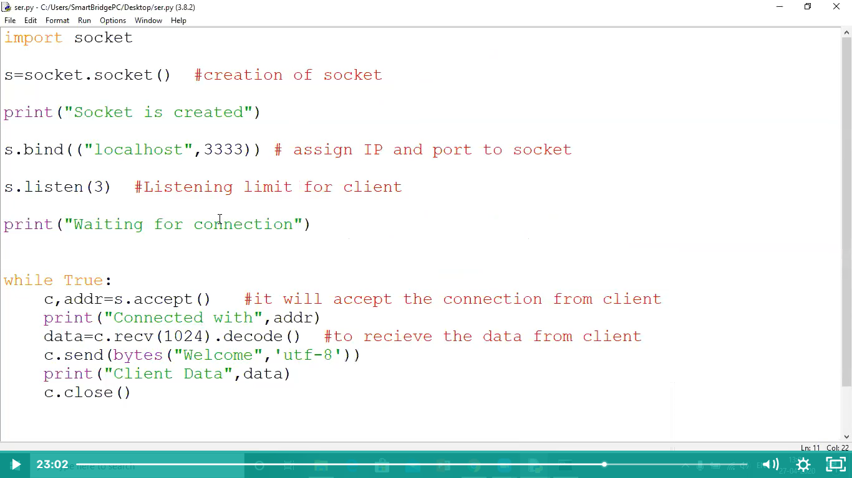

**Fig 9:** Socket Programming Code- Creating Socket & Waiting for Connection

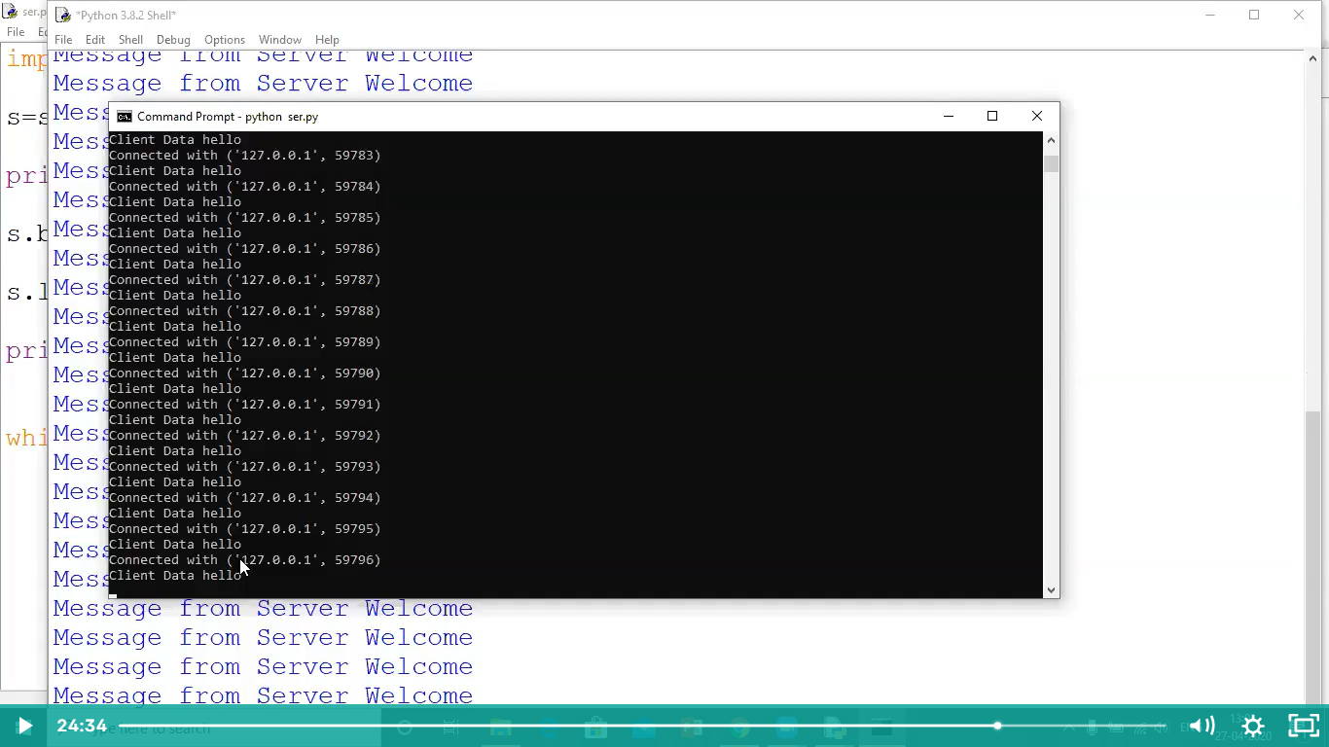

**Fig 10:** Command Prompt Output-Client Data

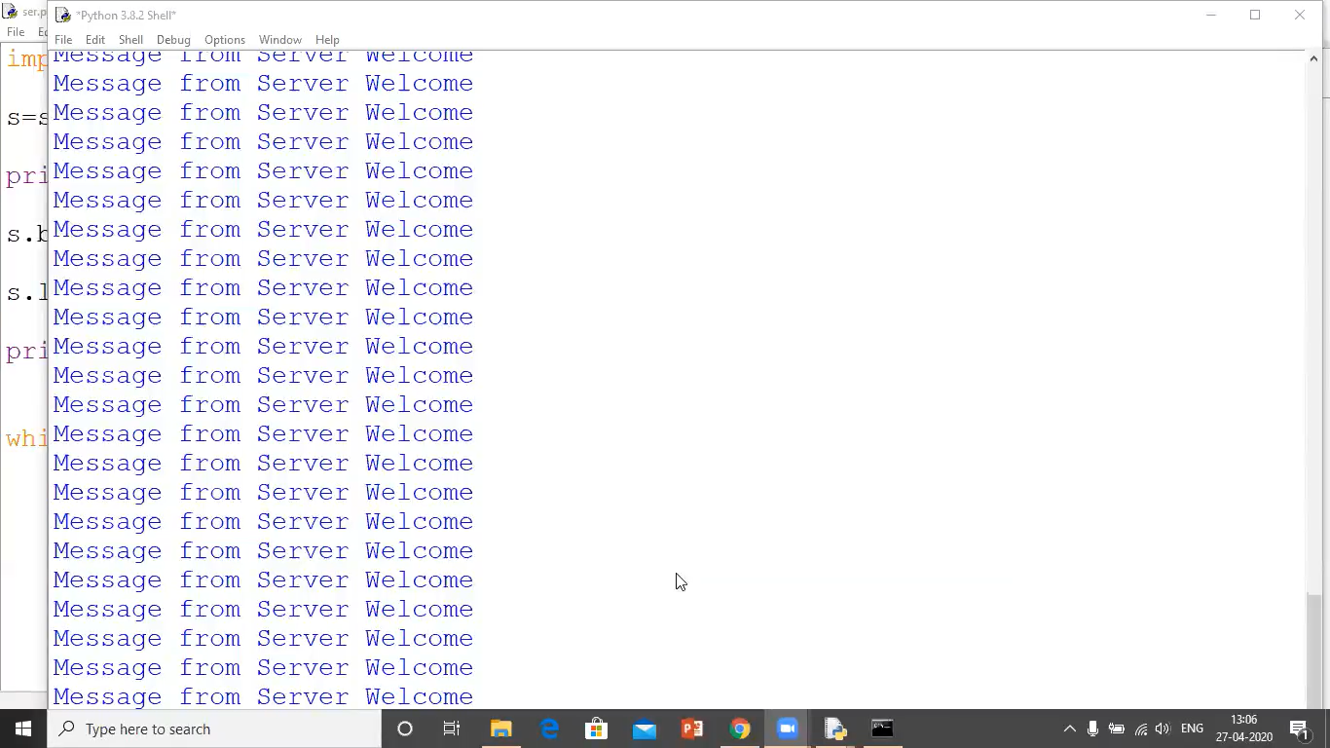

**Fig 11:** Output from Python Compiler - From Server.

**CHAPTER 02**

1. **: IoT Communication Technologies and Protocols:**

**2.0.0 Communication Technologies:**

Several Communication Protocols and Technology used in the internet of Things. Some of the major IoT technology and protocol (IoT Communication Protocols) are Bluetooth, Wi-Fi, Radio Protocols, LTE-A, and Wi-Fi-Direct. These IoT communication protocols cater to and meet the specific functional requirement of an IoT system.

There are 6 IoT Communication Protocols/ Technology, let us look each one of them.

1. **Bluetooth:**
   * A Wireless technology standard for exchanging data over short distances.
   * Common use of Bluetooth technology is in hands-free devices such as headsets used with mobile phones.
   * Uses short-wavelength UHF radio waves in the ISM band from 2.4 to 2.485 GHz.
   * Bluetooth waves typically can only travel 33 feet or less.
   * Bluetooth networks referred to as piconets use a master/slave model to control.
   * A single master device can be connected to up to seven different slave devices.

**Bluetooth Addresses:**

* Every Single Bluetooth Device has a unique 48-bit address, abbreviated as BD_ADDR, presented in the form of a 12-digit hexadecimal value.
* The most-significant half – organization unique identifier (OUI)
* The lower 24-bits – unique part of the address.

**Connection Process:**

* **Inquiry** – If two Bluetooth devices know absolutely nothing about each other, one must run an inquiry to try to **discover** the other.
* **Paging (Connecting)** - Paging is the process of forming a connection between two, Bluetooth devices. Before this, each device needs to know the address of the other (found in the inquiry process).
* **Connection**
  + **Active Mode –** This is the regular connected mode.
  + **Sniff Mode –** This is a power saving mode.
  + **Hold Mode –** Hold mode is a temporary, power-saving mode.
  + **Park Mode –** Park is the deepest of sleep modes.

**Bluetooth Low Energy:**

BLE is meant for situations where battery life is preferred over high data transfer speeds.

**Applications:**

* Mesh Profiles
* Health Care Profiles
* Sports and Fitness Profiles
* Asset Tracking
* Indoor Navigation

1. **Zigbee:**
   * Zigbee is an IEEE 802.15.4- based specification for a suite of high-level communication protocols used to create PAN.
   * Consumes less power.
   * Cost-effective wireless technology
   * Zigbee is low-power, low data rate, and close proximity wireless ad hoc network.

**Device Types:**

* Zigbee Coordinator (ZC)
* Zigbee Router (ZR)
* Zigbee End Device (ZED)

1. **Wi-Fi:**
   * WIFI (WLAN) utilizes the IEEE 802.11 standard.
   * WIFI provides Internet access to devices that are within the range 66 feet from AP.
   * Under ideal conditions, 2.4 GHz Wi-Fi will support up to 450 Mbps or 600 Mbps, depending on the class of the router, 5 GHz Wi-Fi will support up to 1300 Mbps.

**Access Point Mode:**

* An Access Point connects wired and wireless networks together and enables the sending and receiving of data between wireless clients and the wired network.
* The wireless SSID, also known as the ‘Network Name’ is the Service Set Identification controls access to a given wireless network.

1. **RFID:**
   * RFID belongs to a group of technologies referred to as Automatic Identification and Data Capture (AIDC)
   * Radio-frequency Identification (RFID) uses electromagnetic fields to automatically identify and track tags attached to objects. The tags contain electronically stored information.
   * An RFID system consists of a reader, which emits an RF signal via an antenna. The chip receives the energy via an attached antenna (termed an RFID) and modulates the RF signal in order to respond through its antenna so that information can be transferred to the reader.
   * Short range RFID is about 10cm, but long range can go up to 200m.
   * Passive tags collect energy from a nearby RFID reader’s interrogating radio waves.
   * Active tags have a local power source (such as a battery) and may operate hundreds of meters from the RFID reader.
2. **NFC:**

Near-Field Communication (NFC) is a set of communication protocols that enable two electronic devices, one of which is usually a portable device such as a Smartphone, to establish communication by bringing them within 4 cm.

* Uses electromagnetic induction between two loop antennas located within each other’s near field, effectively forming an air-core transformer.
* Frequency: ISM band of 13.56 MHz on ISO
* Data rates: 106 Kbits/s.

1. **LoRa:**
   * LoRa (Long Range) is a spread spectrum modulation technique derived from chirp spread spectrum (CSS) technology
   * Lora can achieve a distance of 15-20 km
   * Lora can achieve high distance communication without using much power
   * Operates on very low bandwidth (Max 5.5Kbps)
     1. **Communication Protocol:**

A communication protocol is a system of rules that allow two or more entities of a communications system to transmit information via any kind of variation of a physical quantity. The protocol defines the rules, syntax, semantics and synchronization of communication and possible error recovery methods.

There are some Communication Protocols. Let’s look at them:

1. **HTTP:**

* The Hypertext Transfer Protocol (HTTP) is an application-level protocol
* HTTP is a TCP/IP based communication protocol
* Used to deliver data (HTML files, image files, query results, etc.) on the World Wide Web.
* The default port is TCP 80.

**Features:**

* HTTP is Connectionless
* HTTP is media Independent
* HTTP stateless

**Difference between GET and POST**

|  |  |  |
| --- | --- | --- |
|  | **GET** | **POST** |
| BACK button/Reload | Harmless | Data will be re-submitted (the browser should alert the user that the data are about to be re-submitted) |
| Bookmarked | Can be bookmarked | Cannot be bookmarked |
| Cached | Can be cached | Not cached |
| Encoding type | application/x-www-form-urlen coded | application/x-www-form-urlen coded or multipart/form-data. Use multipart encoding for binary data. |
| History | Parameters remain in browser history | Parameters are not saved in browser history. |
| Restrictions on data type | Yes, when sending data, the GET method adds the data to the URL; and the length of a URL is limited (maximum URL length is 2048 characters) | No restrictions |
| Restrictions on data types | Only ASCII characters allowed | No restrictions. Binary data is also allowed. |
| Security | GET is less secure compared to POST because data sent is part of the URL  Never use GET when sending passwords or other sensitive information! | POST is a little safer than GET because the parameters are not stored in browser history or in web server logs. |
| Visibility | Data is visible to everyone in the URL | Data is not displayed in the URL. |

**Table 4**: Difference between GET and POST

**2. HTTP Client Request:**

* An HTTP exchange takes place over a TCP/IP socket.
* The client opens a socket
* Connects to the HTTP server via the port the server is listening to, and issues a command.
* The command is routed to the server via the internet
* The server receives the command and does something, typically involving a file lookup.

**3. HTTP Status Codes:**

|  |  |
| --- | --- |
| **S.NO** | **Code and Description** |
| 1 | 1xx: Informational  This means request received and continuing process. |
| 2 | 2xx: Success  This means the action was successfully received, understood, and accepted. |
| 3 | 3xx: Redirection  This means further action must be taken in order to complete the request. |
| 4 | 4xx: Client Error  This means the request contains bad syntax or cannot be fulfilled |
| 5 | 5xx: Server Error  This server failed to fulfill an apparently valid request |

**Table** **5:** HTTP Status Codes

**2xx: Successful**

|  |  |
| --- | --- |
| **Message** | **Description** |
| 200 OK | The request is OK |

**Table 6:** 2xx Successful

**4xx: Client Error**

|  |  |
| --- | --- |
| **Message** | **Description** |
| 400 Bad Request | The server did not understand the request |
| 401 Unauthorized | The requested page needs a username and a password |
| 403 Forbidden | Access is forbidden to the requested page |
| 404 Not Found | The server cannot find the requested page |

**Table 7:** 4xx Client Error

**4. HTTPS:**

* Hyper Text Transfer Protocol Secure (HTTPS) is the secure version of HTTP. It uses SSL/TLS for secure encrypted communications.
* SSL (Secure Socket Layer) is a cryptographic protocol enhancement to HTTP, which defines how client and server should communicate with each other securely. TLS (Transport Layer Security) is the successor of SSL.
* The default port number for https is 443.
* Although HTTPS is secure by its design, the SSL/TLS handshake process consumes a significant time before establishing an HTTPS connection. It normally cost 1-2 seconds and drastically slows down the startup performance of a website.

1. **MQTT:**
   * When a device (a client) wants to send data to the broker, we call this operation a “publish”.
   * When a device (a client) wants to receive data from the broker, we call this operation a “subscribe”.

**Broker:**

* The broker is responsible for receiving all messages, filtering the messages, determining who is subscribed to each message, and sending the message to these subscribed clients.
* A broker has capabilities for both subscribing and publishing.
* Its primary function is to queue the received messages from the publisher and transmit the messages received to the subscriber client accordingly.

**QoS: Quality of Service:**

* The Quality of Service (QoS) level is an agreement between the sender of a message that defines the guarantee of delivery for a specific message.
* There are 3 QoS levels in MQTT:
  + **At most once (0):** This does not guarantee if a message has been delivered successfully.
  + **At least once (1):** This guarantee the message will be delivered at least once. But cab be sent more than once.
  + **Exactly once (2):** This guarantees that the message is sent only once.
* The higher the QoS, the higher it consumes bandwidth to process the transmission.
  1. **: IBM Cloud Platform**

**Cloud:**

Cloud Computing is simply on-demanded delivery of computing services over the internet.

Cloud Computing is categorized into different service models:

* Software as a Service (SaaS)
* Platform as a Service (PaaS)
* Infrastructure as a Service (IaaS)

**Software as a Service (SaaS):**

* Simplest to use and easier to deploy
* No software to install or configure
* Everything is available by web browser.
* Microsoft’s office and slack two popular SaaS products.

**Platform as a Service (PaaS):**

* Developers and programmers upload their content to pre-configured servers.
* No installation or maintaining the server software or operating system.

**Infrastructure as a Service (IaaS):**

* Dedicated virtual systems that you manage and maintain yourself.
* Greatest degree of flexibility and customization in cloud computing.
* Amazon web services (AWS) and Digital Ocean are widely known as IaaS provider.

**2.1.0: Introduction to IBM cloud and IBM its Architecture:**

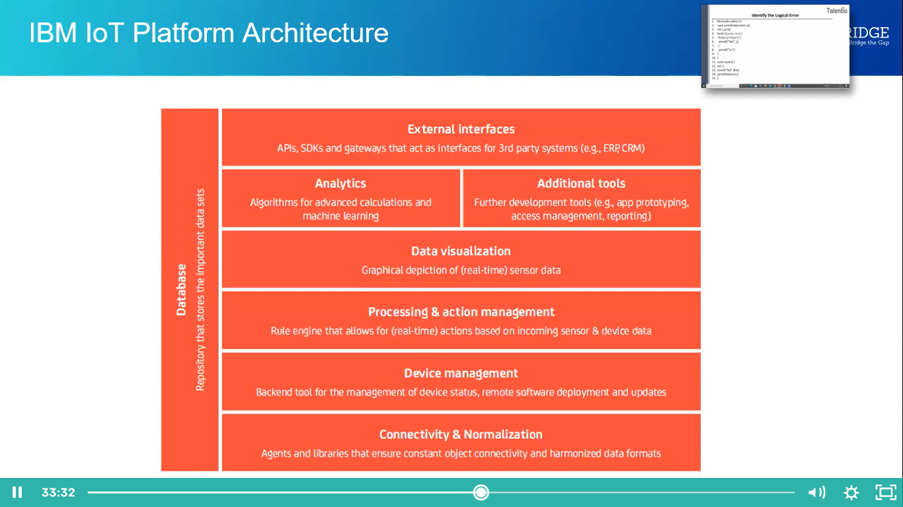

**Fig 12:** IBM IoT Platform Architecture

* 1. Connectivity & Normalization: Brings different protocols and different data formats into one “software” interface ensuring accurate data streaming and interaction with all devices.
  2. Device Management: Ensures the connected “things” are working properly, seamlessly running patches and updates for software and applications running on the device or edge gateways.
  3. Database: Scalable storage of device data brings the requirements for hybrid cloud-base data bases to a new level in terms of data volume, variety, velocity and veracity.
  4. Processing & Action Management: Brings data to life with rule-based event-action-triggers enabling execution of “smart” actions based on specific sensor data.
  5. Analytics: Performs a range of complex analysis from basic data clustering and deep machine learning to predictive analytics extracting the most value out of the IoT data-stream.
  6. Visualization: Enables humans to see patterns and observe trends from visualization dashboards where data is vividly portrayed through line-, stacked-, or pie charts, 2D- or even 3D-models.
  7. Additional Tools: Allow IoT developers prototype, test and market the IoT use case creating platform ecosystem apps for visualizing, managing and controlling connected devices.
  8. External Interfaces: Integrate with 3rd-party systems and the rest of the wider IT-ecosystem via built-In application programming interfaces (API), software development kits (SDK), and gateways.
     1. **IBM IoT Device creation and connecting Internal Simulator:**

Steps for IBM IoT device creation and connecting Internal Simulator:

* + 1. First we have to Create IBM Cloud Account at [**https://www.ibm.com/in-en/cloud**](https://www.ibm.com/in-en/cloud) **.**
    2. Next we have login into our account.
    3. You will display the IBM dashboard. In that dashboard you can see our active IBM Services.
    4. Click on catalog we will get the list of the services provided by the IBM Cloud.
    5. Create Internet of Things Service.
    6. After service is Created, we have to add devices to the IoT Platform.
    7. We can add the devices like Raspberry Pie, Arduino etc.
    8. We have to connect device to the IBM virtual IoT simulator <http://watson-iot-sensor-simulator.mybluemix.net/> .

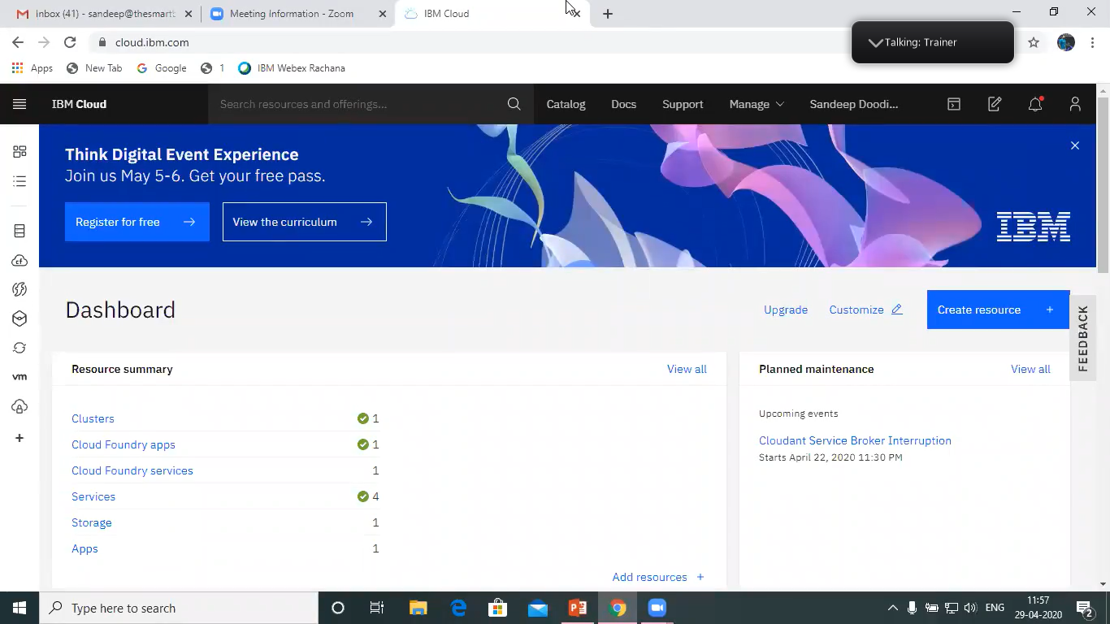

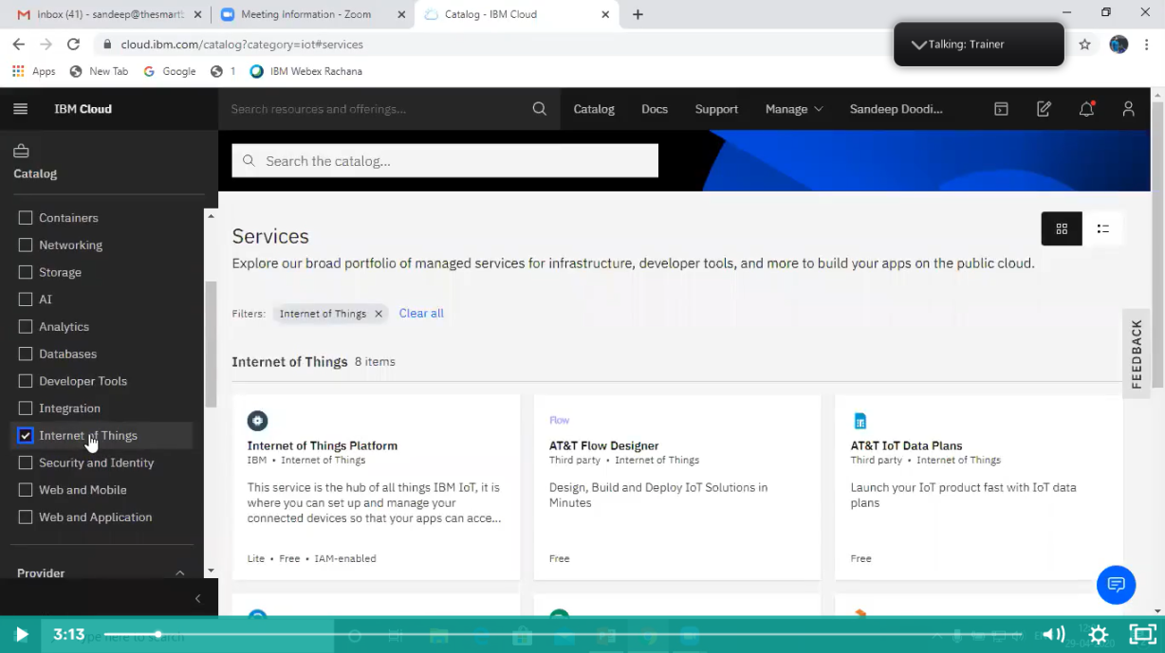

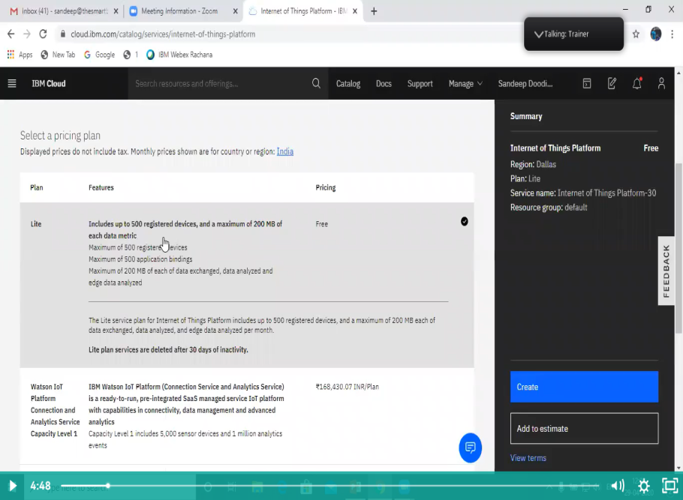

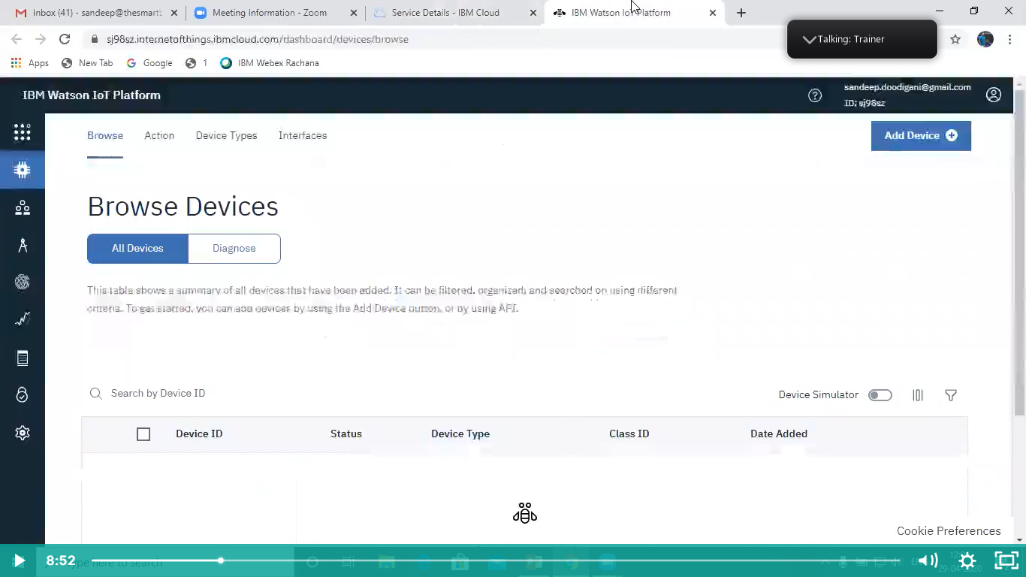

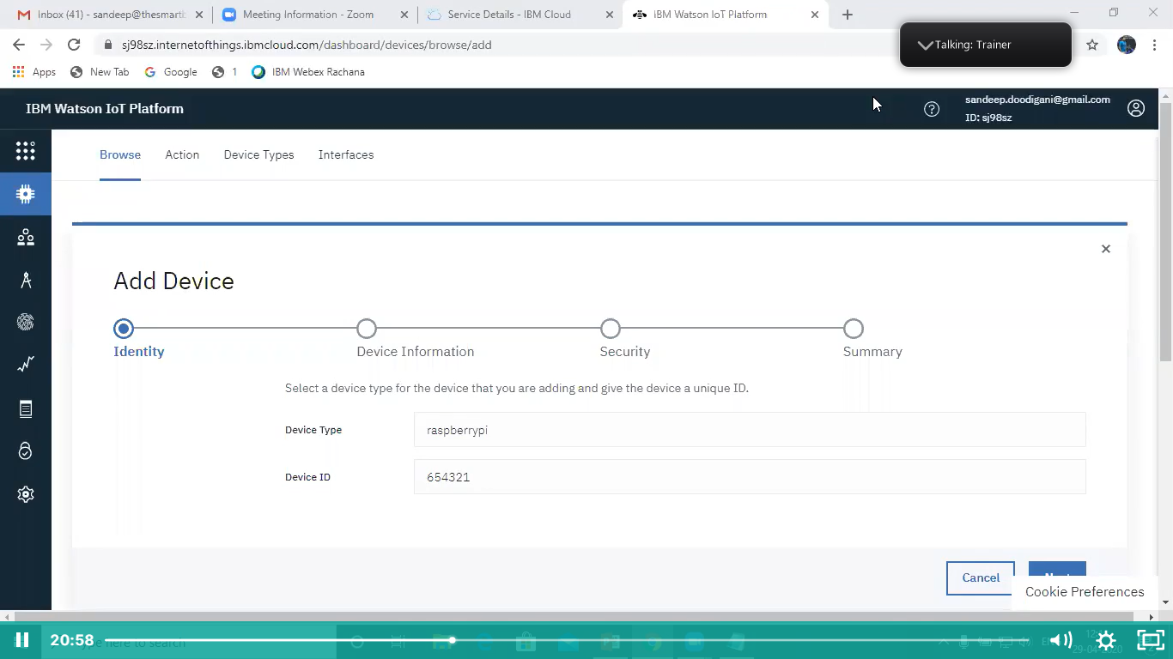

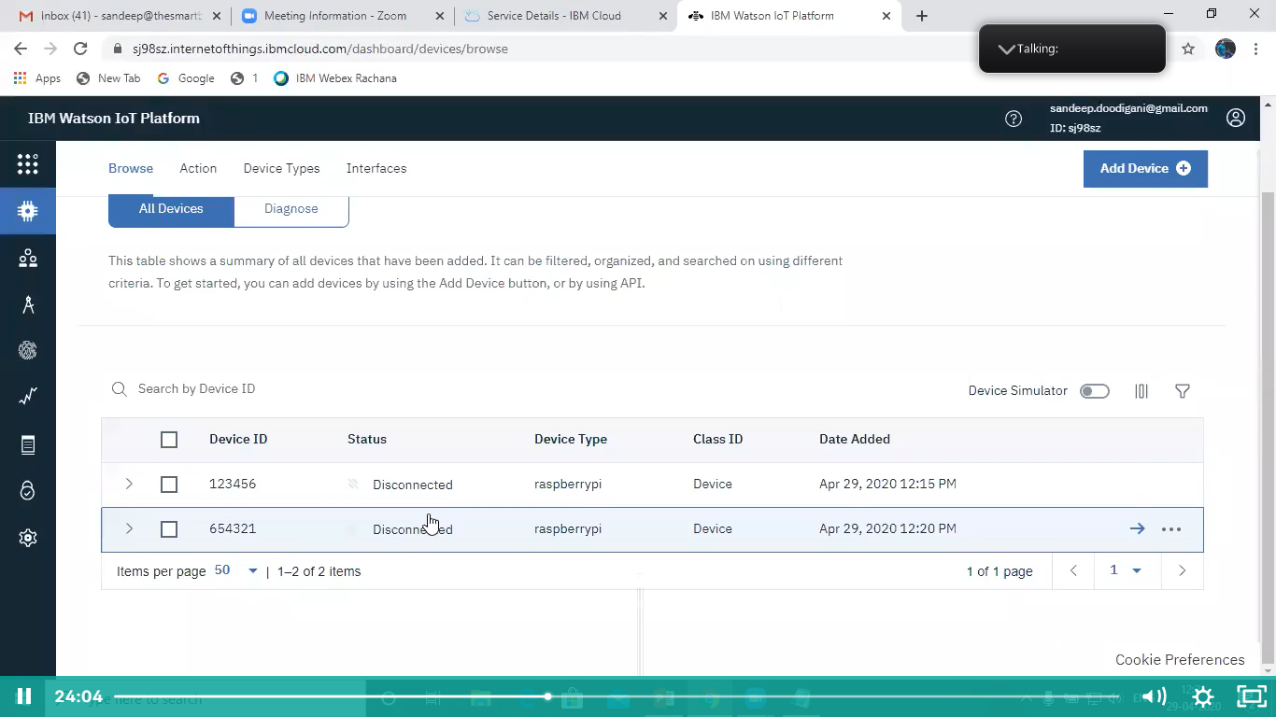

**Fig 13:** IBM account Creation &IoT Service

**2.1.2 Connecting to IBM IoT Platform and sending sensor data using python code:**

* Previously we created IoT Platform and connected to Virtual IBM IoT simulator.
* Now we using python code to perform IoT
* By using Device data in the IoT Platform we can send data by using the Python code.
* To use Python code, we have to install some library files.
* We can check whether the required library files are available in our laptop/Computer by using command prompt.
* For installation use **pip install ibmiotf**in command prompt

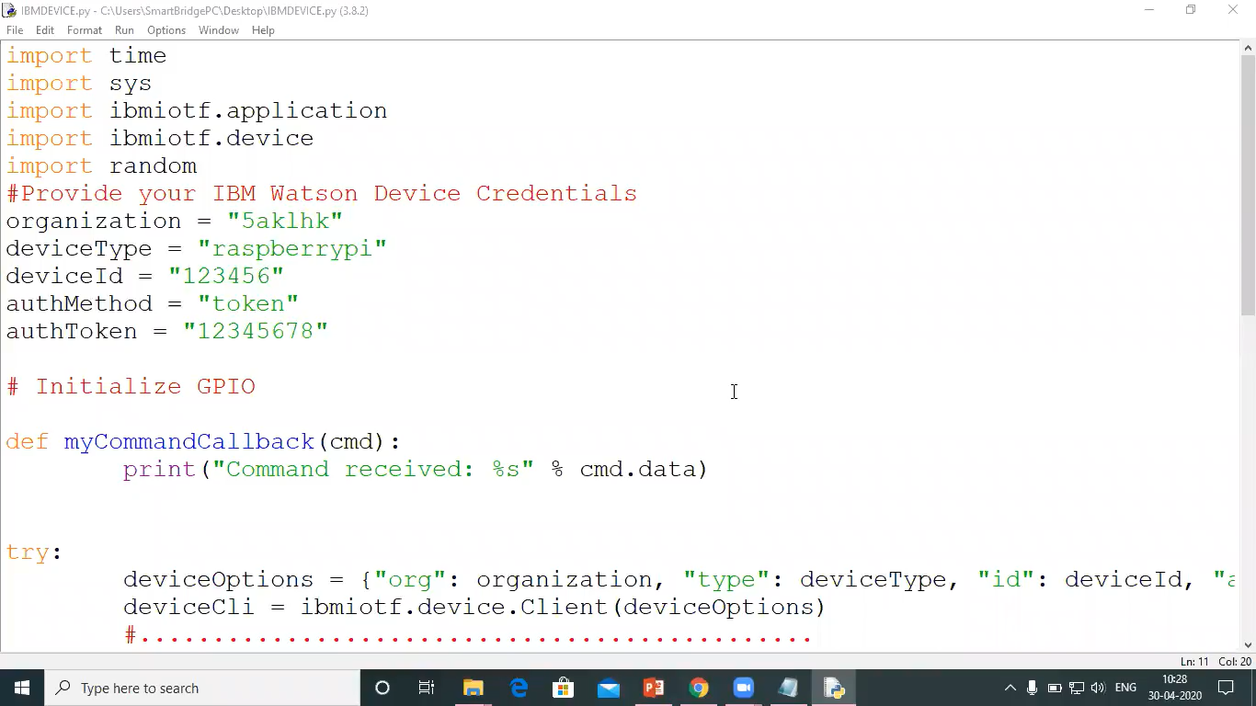

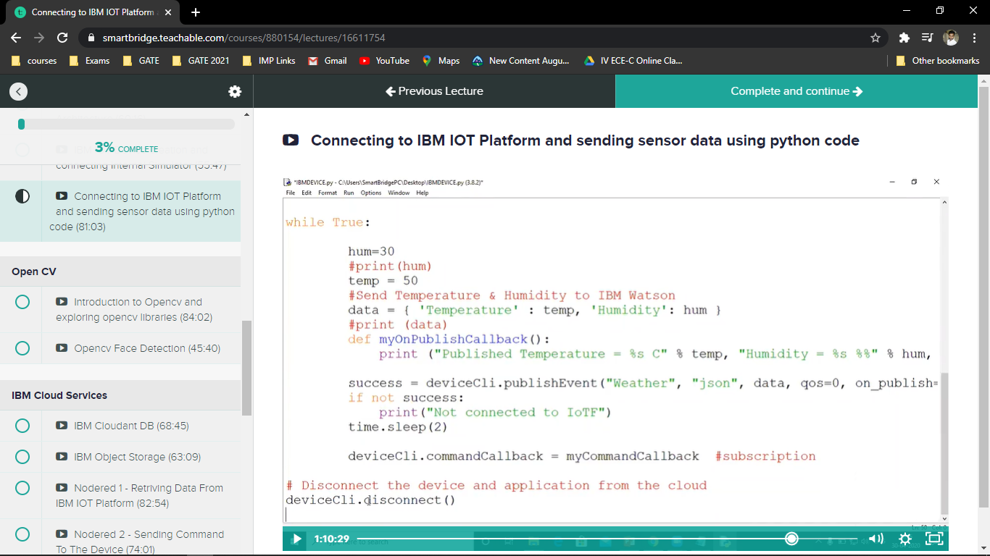

**Fig 14:** Python Programming to send data

**CHAPTER 03**

**3.0 IBM Cloud Services**

**3.0.0 IBM Cloudant:**

What is IBM Cloudant?

IBM Cloudant is a fully managed JSON document database that offers independent serverless scaling of throughput capacity and storage.

How to open IBM Cloudant and use it?

First fall open IBM cloud and there will open a dashboard page and click on catalog and there will see all the services of IBM. and click on catalog then left side we see services option click on it and search for Cloudant, and there will see a Cloudant data base and click on it.

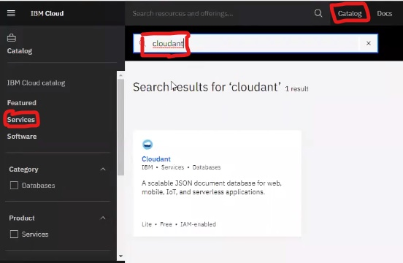

**Fig 15:** Cloudant in catalog page

In Cloudant we store the data in JSON format. The Cloudant page will be open and fill necessary credentials and click on create.

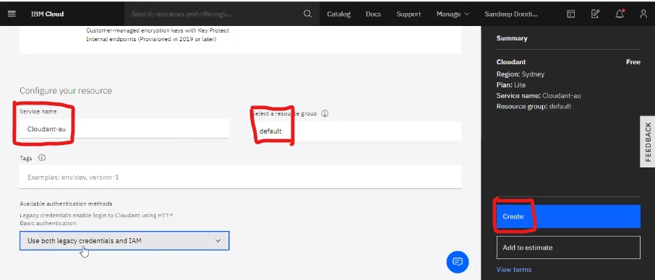

**Fig 16:** Cloudant database creating page

Now open Cloudant service and click on launch dashboard page.

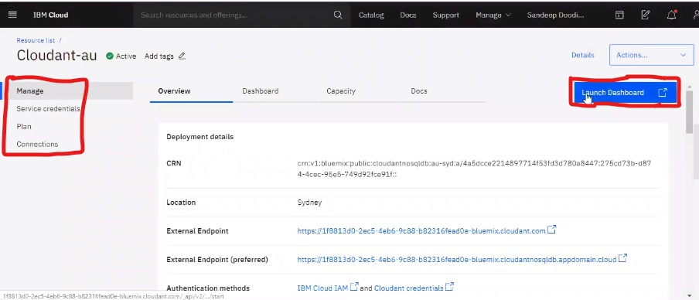

**Fig 17:** Cloudant launch dashboard

And database page will be open for us. and click on create database and there a pop page will be open on right side and create a database name and there we have an option is partitioning in that we have to click on non-partitioned and then click on create button.

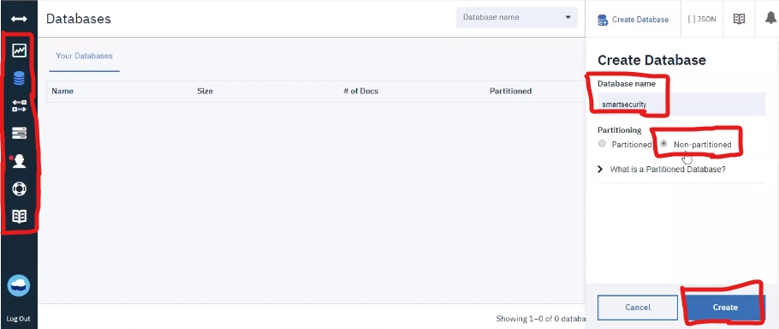

**Fig 18:** Creating database

And we create our data here and document will be created in it. To run the python code in it. We have to open database page and check data is created or not.

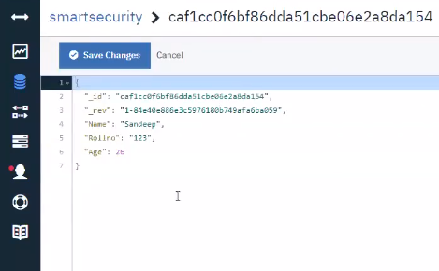

**Fig 19:** Editor page

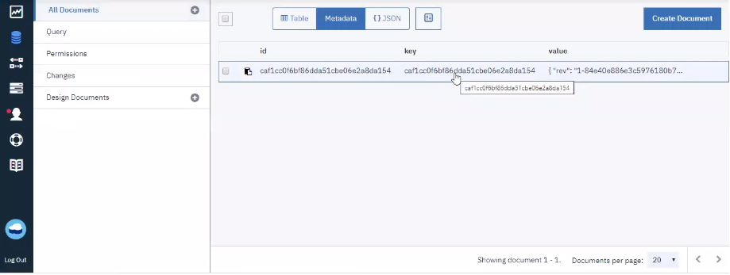

**Fig 20:** Data is created in j.son format

**3.0.1 IBM Object Storage:**

What is IBM object storage?

IBM Object Storage makes it possible to store practically limitless amounts of data, simply and cost effectively. It is commonly used for data archiving and backup; for web and mobile applications; and as scalable, persistent storage for analytics.

How to open IBM Object Storage and use it?

First fall open IBM cloud and there will open a dashboard page and click on catalog and there will see all the services of IBM. and click on catalog then left side we see a services option click on it. Search for Object Storage, there we observe Object Storage then click on it.

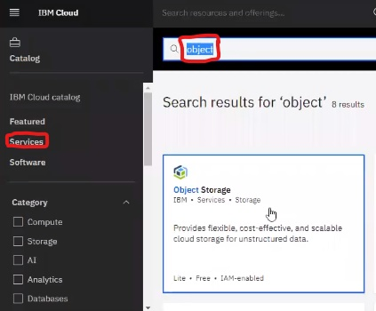

**Fig 21: Object storage**

Object storage page will be open then click on create option then service will be created.

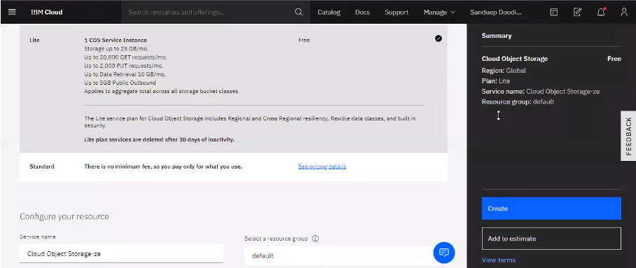

**Fig 22:** Creating object storage

Object storage will be open and click on buckets and then click on create bucket button there are different kind of buckets are there. We have to click on custom bucket and bucket should always be unique name and click on create bucket.

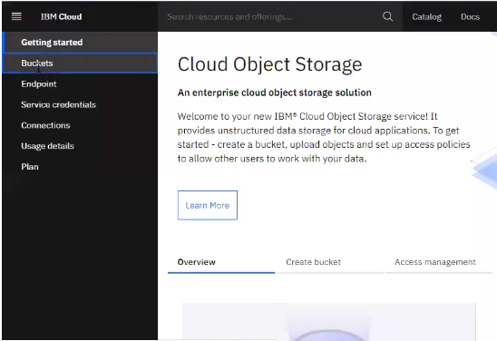

**Fig 23:** Creating buckets

There will have a drag and drop option then click on it. A pop page will be opened and select any file you want to store in it.

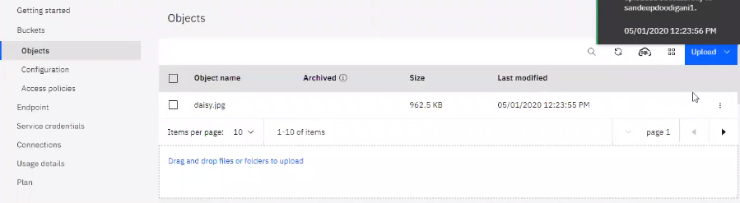

**Fig 24:** Data is stored

**3.1 NODERED**

WHAT IS Node red?

Node-RED is a programming tool for wiring together hardware devices, APIs and online services in new and interesting ways. It provides a browser-based editor that makes it easy to wire together flows using the wide range of nodes in the palette that can be deployed to its runtime in a single-click.

**3.1.0 Retrieving Data from IBM IoT Platform:**

First fall open IBM cloud and there will open a dashboard page and click on catalog and there will see all the services of IBM. and click on catalog then left side we see software option click on it. and search for Node-red and there will see a Node-Red App then click on it. Node-Red page will be open and back end it operates under Cloudant database. Node-Red is been developed on Node. JS and click on create and give some necessary credentials in it. Then click on Next and duplicate the same page and come back to dashboard page then click on services in that click on internet of things platform then click on launch button. So, it will be launch IBM IoT platform. In node-red page click on IBM cloud and click on cloud foundry apps in that click on Node-Red and then click on Visit App URL. Then welcome page will be open of Node-Red and click on next finally click on finish. And click on Go to Node-Red flow Editor then open the Node-Red tool page. in Node-Red left side we have filter nodes and middle page we have work bench and right side we have console and every time we have to click on Deploy to save the flow. Connect necessary nodes and click on Deploy to save the flow of the Node-Red, in right side of the corner we have two buttons one is Node information and other one is Debug messages and then click on the button on work bench then we see the debug information on the right side of the debug message area. We have to Retrieving Data from IBM IoT Platform and we have installed some libraries in it. Then click on menu button and go to manage palette and click on install and search for IBM IoT and click on install and then click on again install. and left side we have seen IBM IoT nodes and drag the node to work bench and double tab on the IBM IoT and insert API KEY and API token in it and click on add and come back same page then add some credentials in it. and then connected to the IBM IoT platform and whatever data coming in IoT platform that data comes to node-red flow also.

menu

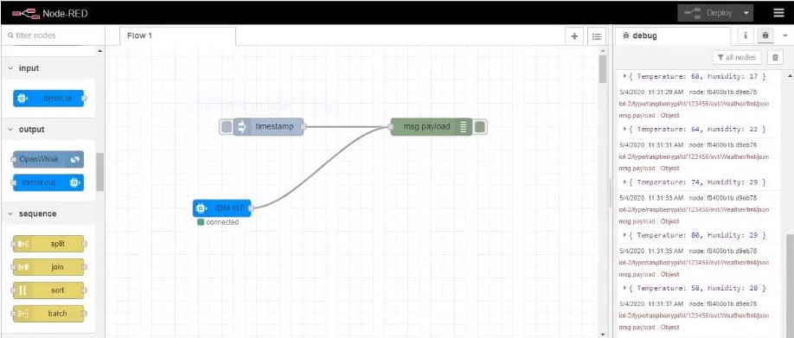

Insert button

Filter node

Console

debug message

Work bench

**Fig 25:** Node-Red flow diagram

**3.1.1 Sending Command to the Device:**

Sending commands to connected device by using IoT simulator. By adding additional functions to it, temperature and humidity functions to it to the message. Payload sees same values in the IoT simulator. Whatever information comes in the node-red. If we want to see the interface of UI then copy the node-red URL and open the new tab and paste URL in Web and add additional term UI in the web lastly and then press enter it is shown as figure.

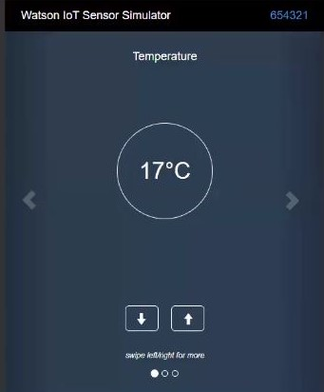

**Fig 26:** IoT Simulator

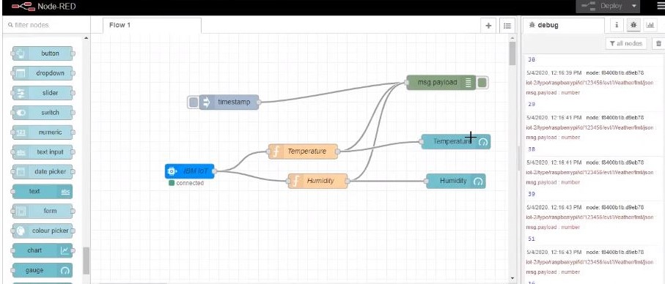

**Fig 27:** Sending command to device

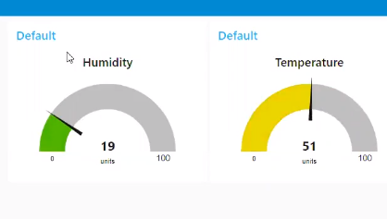

**Fig 28:** Receiving data from web

**3.2 Watson Assistant using python code**

What is Watson assistant?

Watson Assistant is a conversation AI platform that helps you provide customers with fast, straightforward and accurate answers to their questions, across any application, device or channel.Watson Assistant is more than a Chabot.

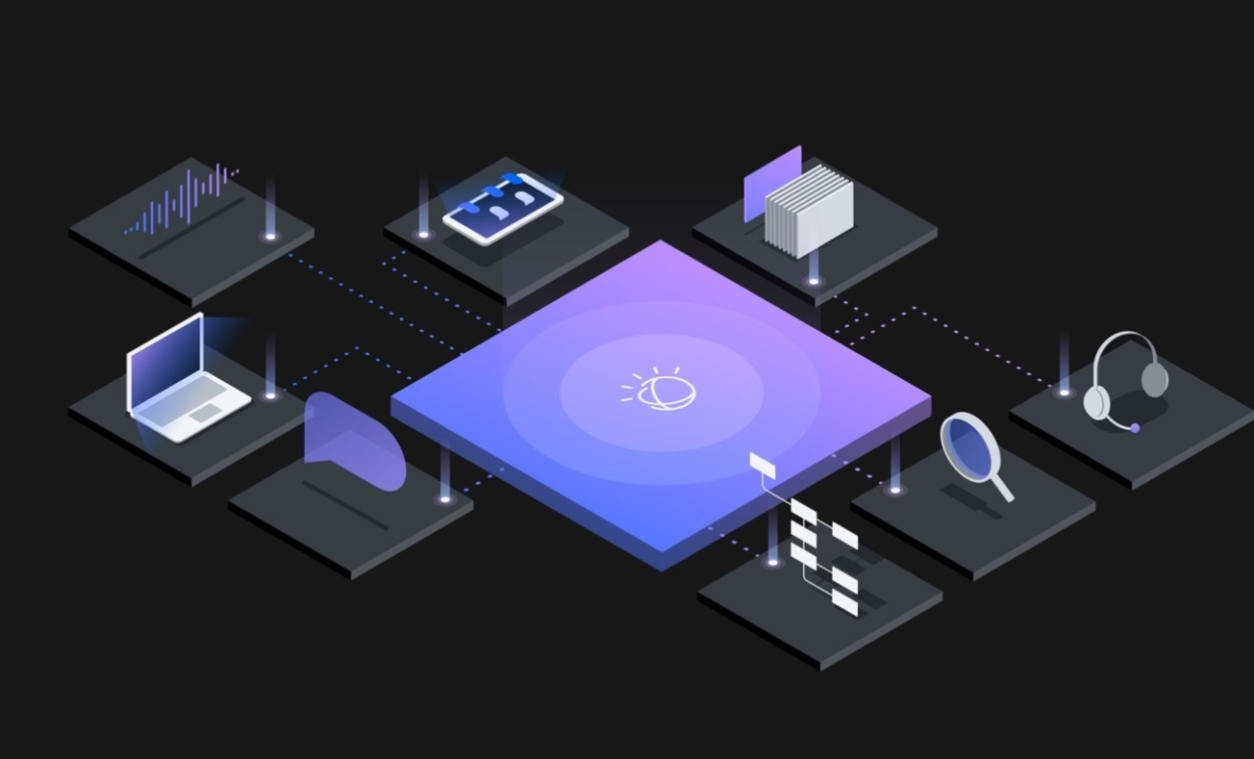

**Fig 29:** Watson assistant AI platform

How to open Watson Assistant and work it?

First fall open IBM cloud and there will open a dashboard page there we will see a services button in service button we have Watson assistant click on it Watson assistant page will be open there we have some credentials in it copy them in one side and paste this credentials in the python code when this credentials needed and click on launch Watson assistant. There you see assistant page we want some libraries in it and download the libraries. we have to create a session to use Watson assistant every time and copy Watson assistant code and paste the code in python shell and paste the API keys and Watson assistant keys in it and run the code in python shell then we get session id copy that id in a notepad carefully. In API docs left side we have methods in methods we have messages in messages select send user input to assistant there we have a python code copy that code and paste the code in python shell and give necessary credentials to it, lastly, we have copied session id and place them in that code and run that python code successfully. We provide some skills to our Watson assistant then Watson assistant is trained successfully.

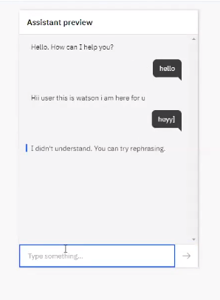

**Fig 30:** Watson assistant preview

**CHAPTER 04**

**4.0 MIT App Inventor:**

What is MIT App Inventor?

* MIT App Inventor is an intuitive, visual programming environment that allows everyone to build fully functional apps for smart phones and tablets. It is free and open-source software.
* It is originally provided by Google, and now maintained by the Massachusetts Institute of Technology (MIT).
* It allows newcomers to computer programming to create application software apps for two operating systems Android, and IOS.

How to download the created app?

1) Click on Build and save.apk file or from the QR code.

2) Install app from play store MIT AI2 Companion. Click on connect and click AI companion.

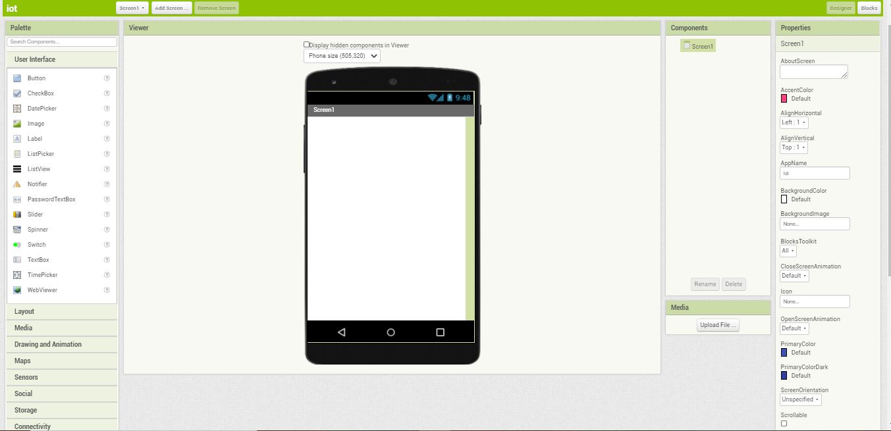

**Fig 31:** Creating a MIT App

**4.1: Applications**

**4.1.0 Smart Tracking (Geofence)**

* Geofences are a great feature of the EyeQ mapping. By drawing virtual fences (geofences) around areas, you’re able to manage when vehicles, assets or personnel have crossed the fence boundary and receive notifications, should they be needed as well.
* By looking at Geofence applications within your own organization, you can utilize improved visibility and reporting metrics to provide a more streamlined and automated process for management of the comings and goings of fleet and assets and the reporting of such.

The following are some of the uses you might have for setting up a geofence:

1. Deport
2. Job & Work Sites
3. Restricted Areas
4. Parks/Regions
5. Disaster Zoning

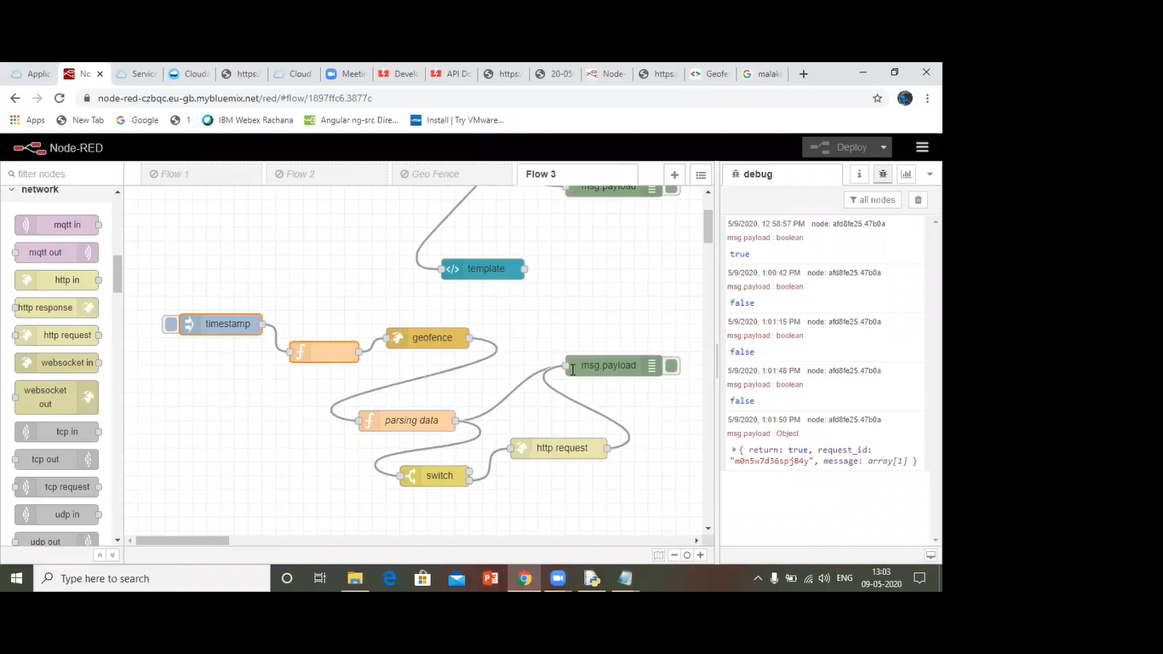

**Figure 32:** Node red Code for Smart Tracking with Geofence

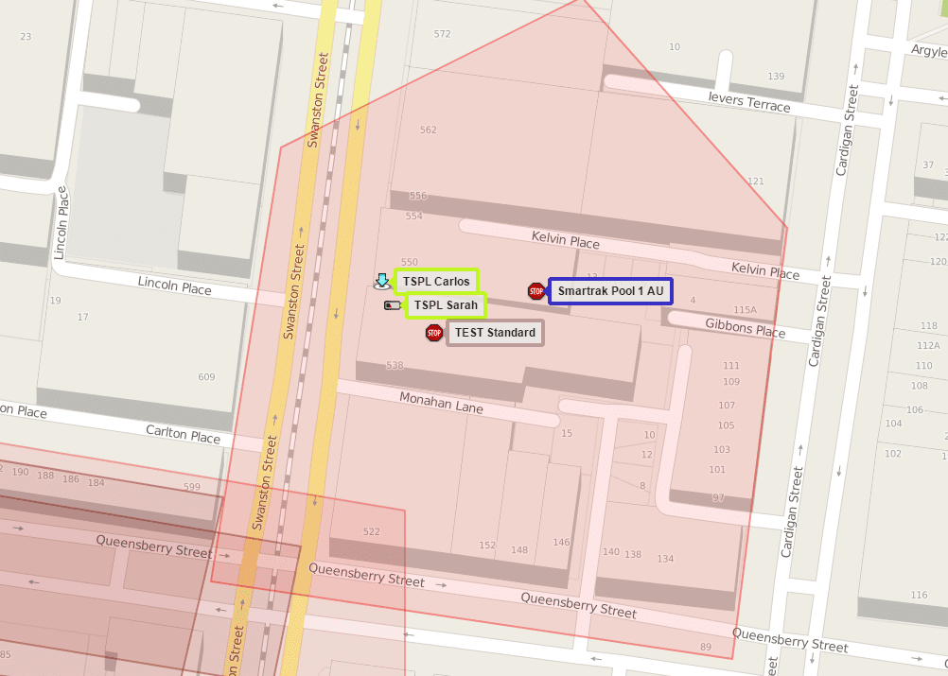

**Figure 33:** Smart Tracking with Geofence

**4.2 IBM Cloud Functions**

* IBM Cloud Functions is a distributed compute service that executes application logic in response to requests from web or mobile apps. You can set up specific actions to occur based on HTTP-based API requests from web apps or mobile apps, and from event-based requests from services like Cloudant. Functions can run your code snippets on demand or automatically in response to events.
* All APIs are protected with HTTP Basic authentication. You can use the wskadmin tool to generate a new namespace and authentication. The Basic authentication credentials are in the AUTH property in your ~/.wskprops file, delimited by a colon. You can also retrieve these credentials by using the CLI running ibmcloudwsk property get --auth.

For the {namespace} in the URL, the underscore character (_) can be used to specify the user's default namespace.

**CHAPTER 05**

**PROJECT**

1. Purpose of the Project
2. Block Diagram
3. Hardware/Software Designing
4. Project code
5. Advantages & Disadvantages
6. Applications
7. Result
8. Conclusions

**5.1: Purpose of the Project**

##### There will a Mobile app for the public through which they can book tickets by seeing the available seats. Through this app the traveler can order the food, the pantry section will get the notification of order. A GPS module is present in the train to track it. The live status of the journey is updated in the mobile app continuously. The user can set a notification for intimating the train live status for both boarding and destination stations.

**5.2:** **Proposed Solution**

This Project examines and compares some IOT regression methods.

Wireless sensor network makes the Railway system smarter and easier. The Railway system is monitored continuously through the sensor network. The traveler personal details are transferred from routers to the main coordinator. At the main controller the GPS module is present to track the live status of train is, based on the QR code traveler can order the food, the pantry section will get the notification order. Traveler personal details along with their order is visualized in the mobile app and also stored in the database. Traveler get his/her order using the mobile app.

**5.3: Block Diagram**

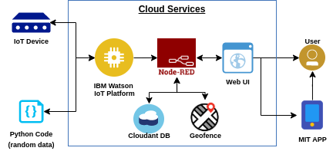

**Fig 34:** Block Diagram of smart railway system based on IoT

**5.4 Hardware/Software Designing**

By using

Python

IOT Open Hardware Platforms

IOT Application Development

IOT Cloud Platform

**5.5 Python Code**

importwiotp.sdk.device

import time

import random

#Provide your IBM Watson Device Credentials

myConfig = {

"identity":{

"orgId":"e6dgwr",

"typeId": "iotdevice",

"deviceId":"1234"

},

"auth”: {

"token":"UK! ox2syaH2ExIhTo1"

}

}

"

# Connect and send a datapointinto the cloud as an event of type

defmyCommandCallback(cmd):

print ("Message received from IBM IoT Platform: %s" % cmd.data['command'])

m=cmd.data['command']

client = wiotp.sdk .device.DeviceClient(config=myConfig, logHandlers=None)

client.connect()

def pub(data):

client.publishEvent(eventId="status", msgFormat="json", data=myData, qos=0, onPublish=None)

print("Published data Successfully: %s", myData)

while True:

myData={'name':'Train1','lat': 8.0883,'lon': 77.5385}

pub(myData)

time.sleep(3)

myData={'name':'Train1','lat': 13.0827,'lon': 80.2707}

pub(myData)

time.sleep(3)

myData={'name':'Train1','lat': 12.9716,'lon': 77.5946}

pub(myData)

time.sleep(3)

myData={'name':'Train1','lat': 17.3850,'lon': 78.4867}

pub(myData)

time.sleep(3)

myData={'name':'Train1','lat': 23.2599,'lon': 77.4126}

pub(myData)

time.sleep(3)

myData={'name':'Train1','lat': 28.7041,'lon': 77.1025}

pub(myData)

time.sleep(3)

myData={'name':'Train1','lat': 33.2778,'lon': 75.3412}

pub(myData)

time.sleep(3)

client.commandCallback = myCommandCallback

client.disconnect())

# Disconnect the device and application from the cloud

deviceCli.disconnect()

**5.6: ADVANTAGES & DISADVANTAGES**

**Advantages:**

1)Greater Reliability and safety

2)Fewer Maintenance delays

3)Advanced Analytics for Streamlined operations

4)Restructured and optimized Passenger Experience

**Disadvantages:**

1) There could be wrong Analysis of Latitudes and Longitudes

2) Difficult in case of failure of GPS module and QR code

**5.7: APPLICATIONS**

We can implement in various fields like

1)Enterprise IT for resource planning, customer relationship Management and decision support systems

2)To be viable stakeholders and contributors in the digital future, rail companies will need to make essential changes in their strategies

**5.8: RESULTS:**

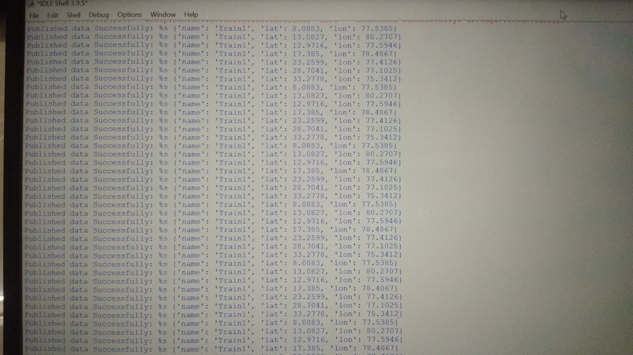

**Fig 35:** Python code output

**NODE-RED:**

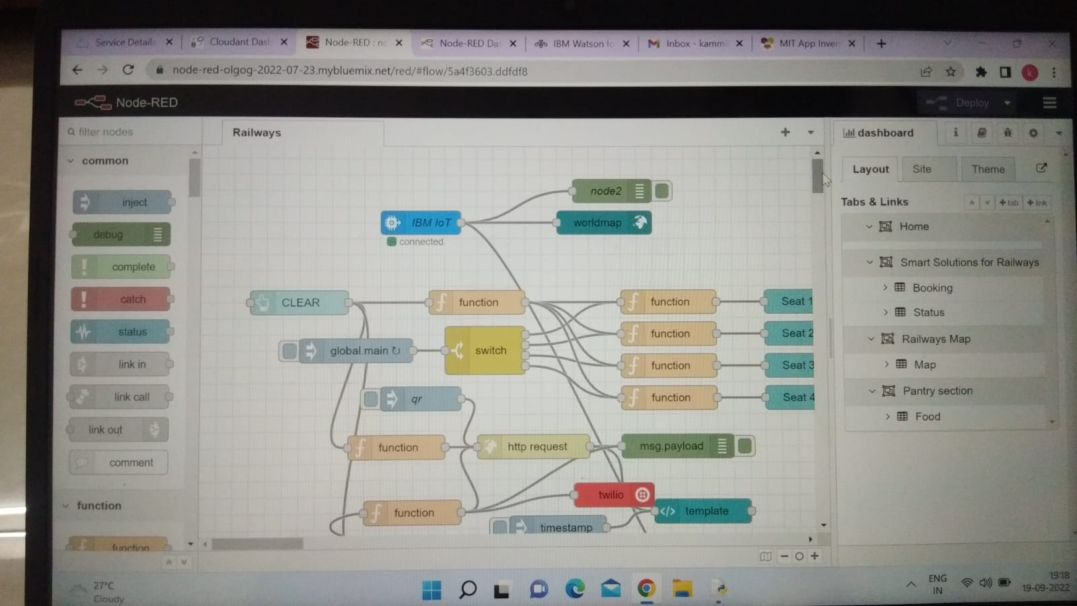

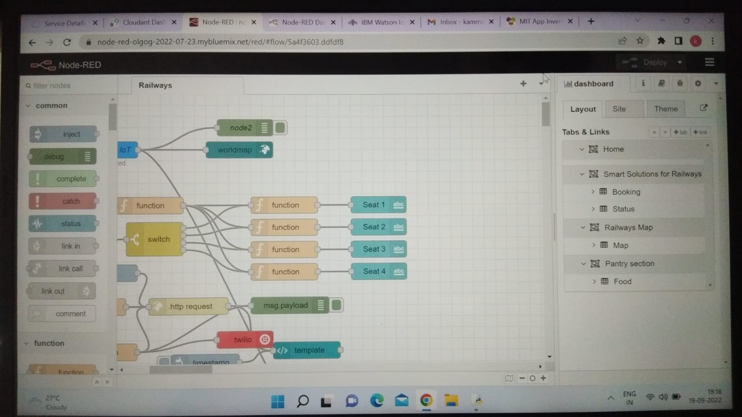

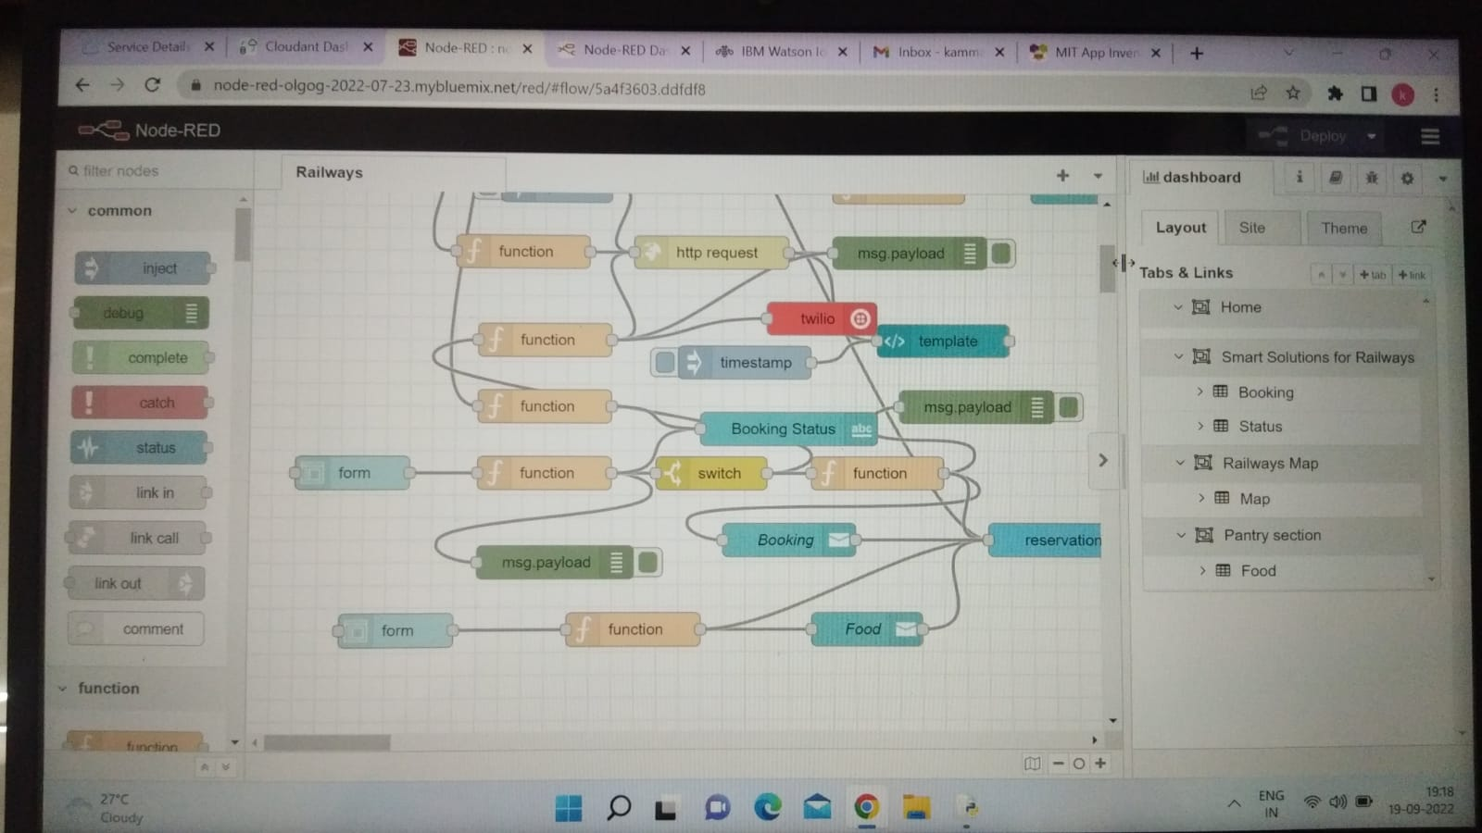

**Fig 36:** Node red flow

**Node-Red UI:**

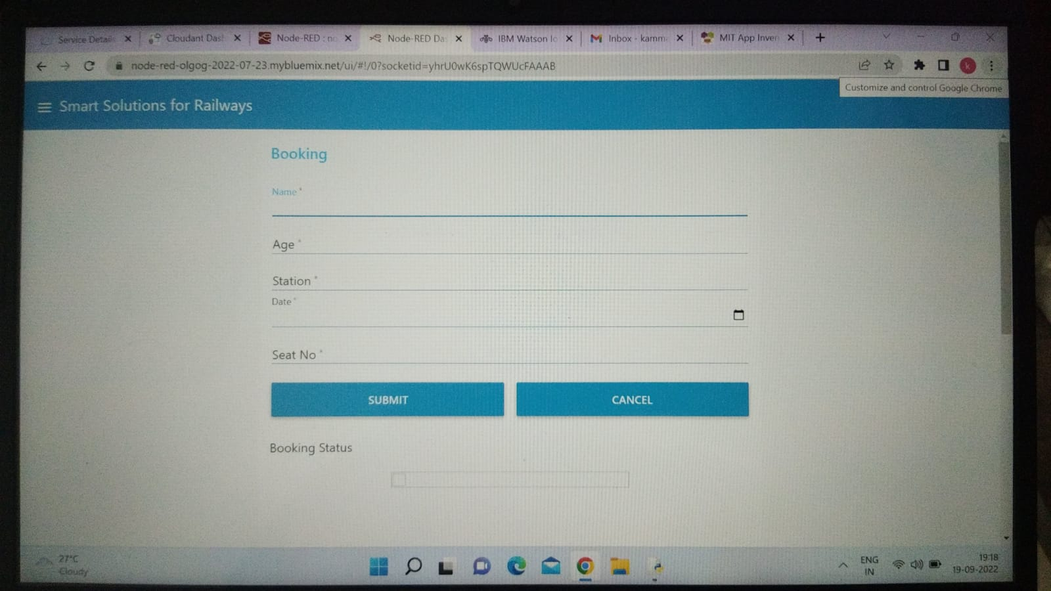

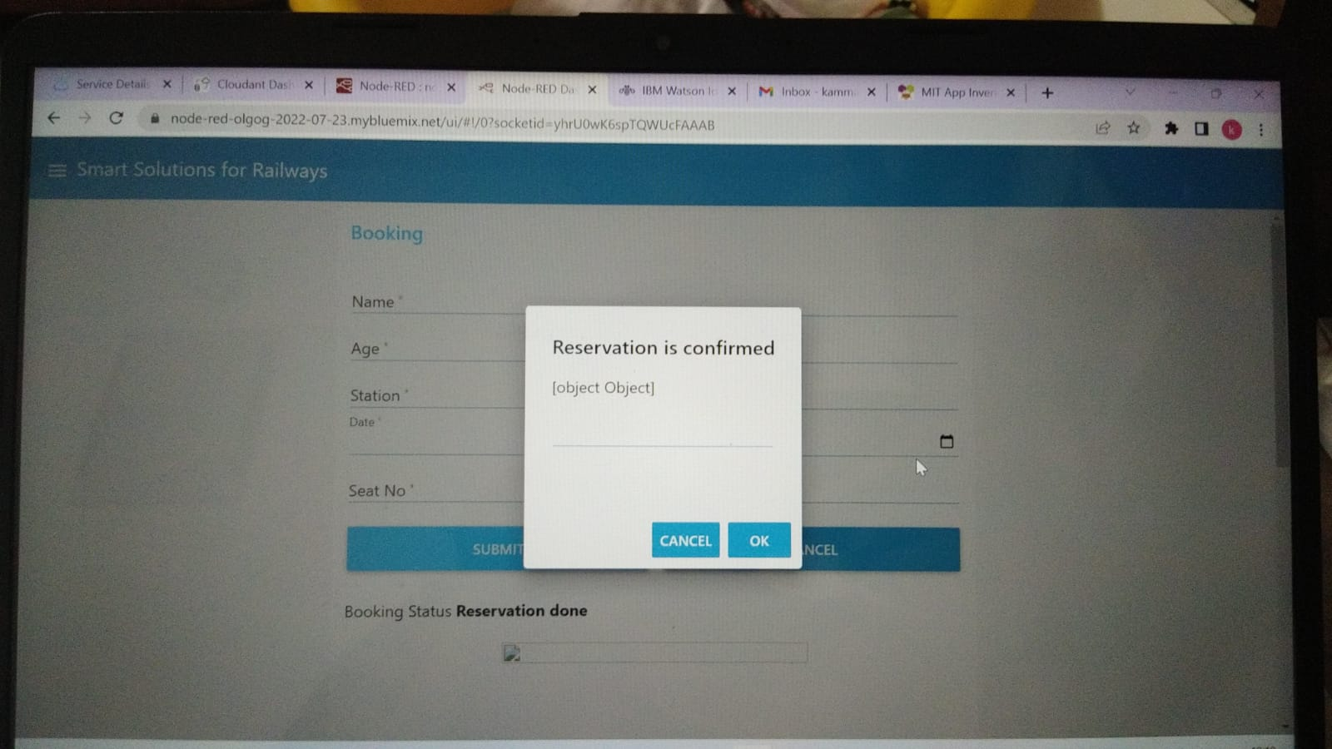

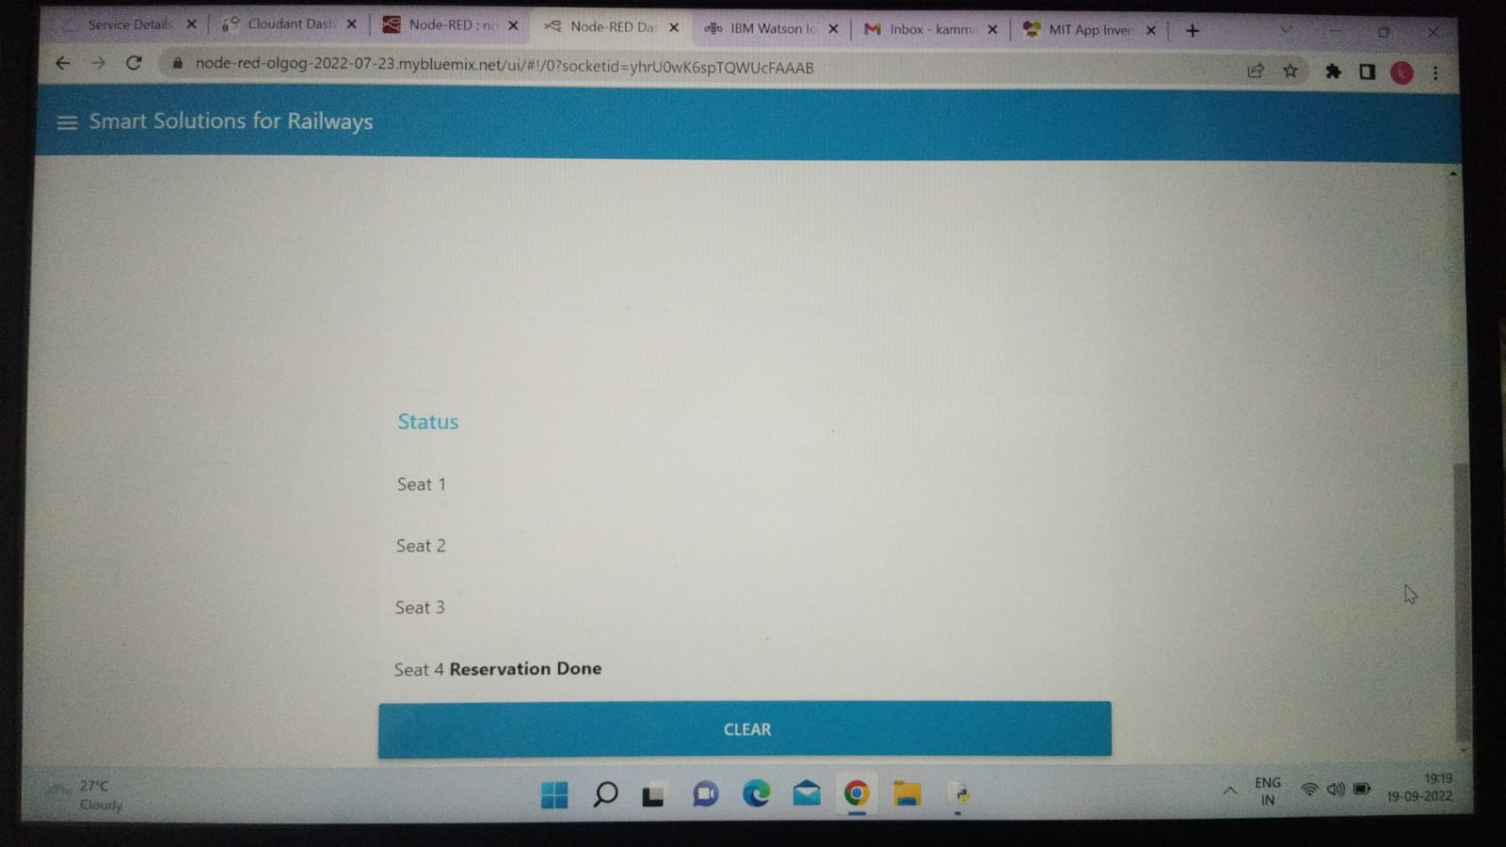

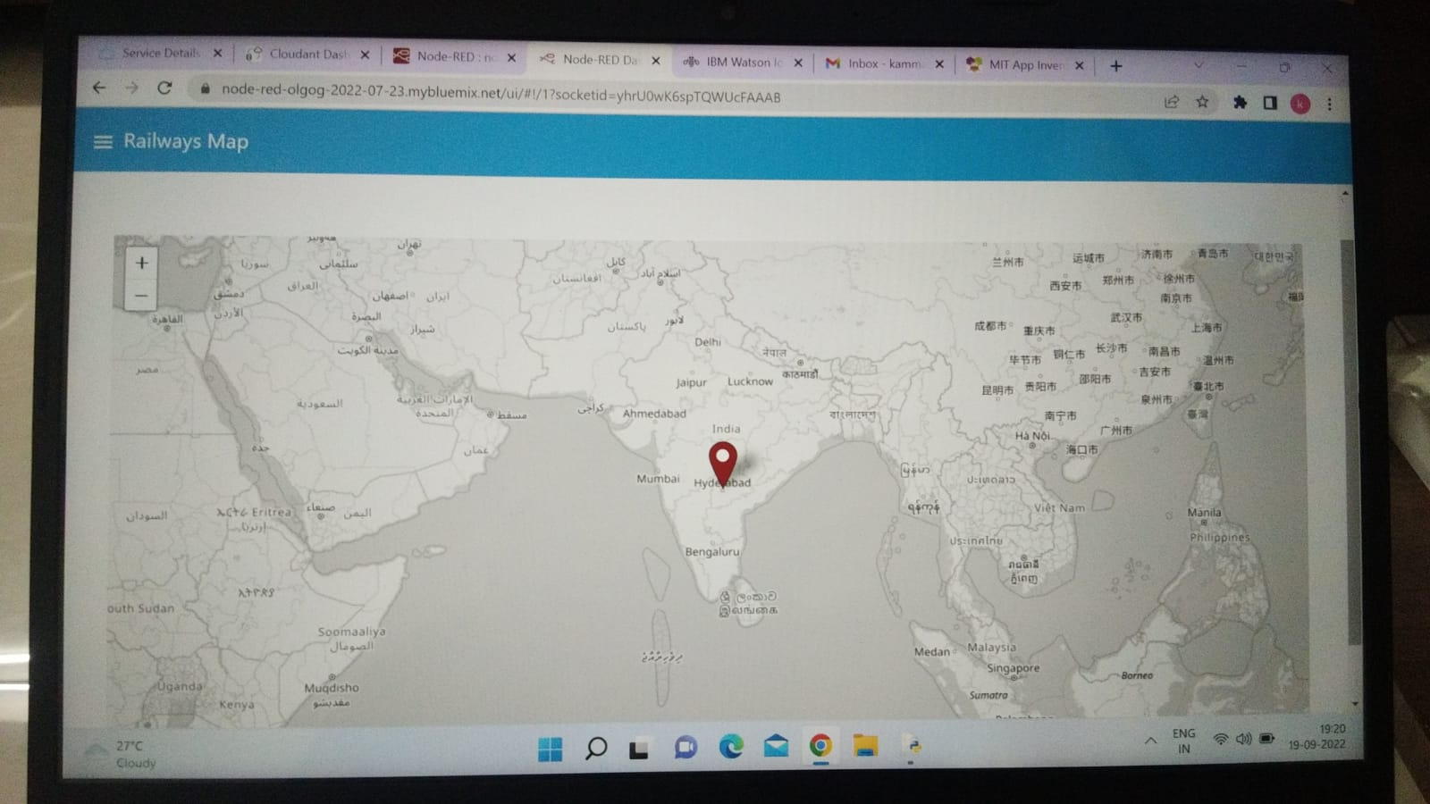

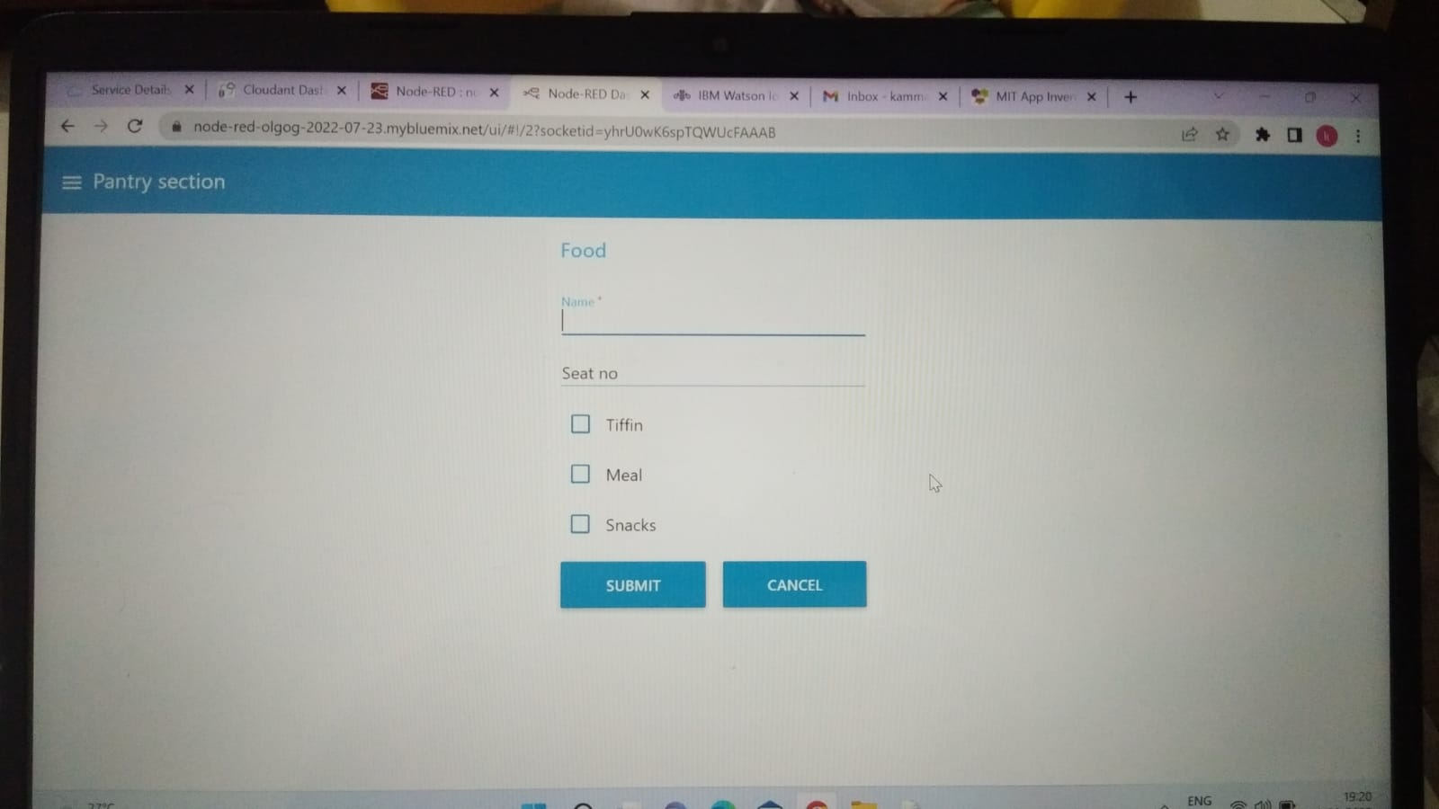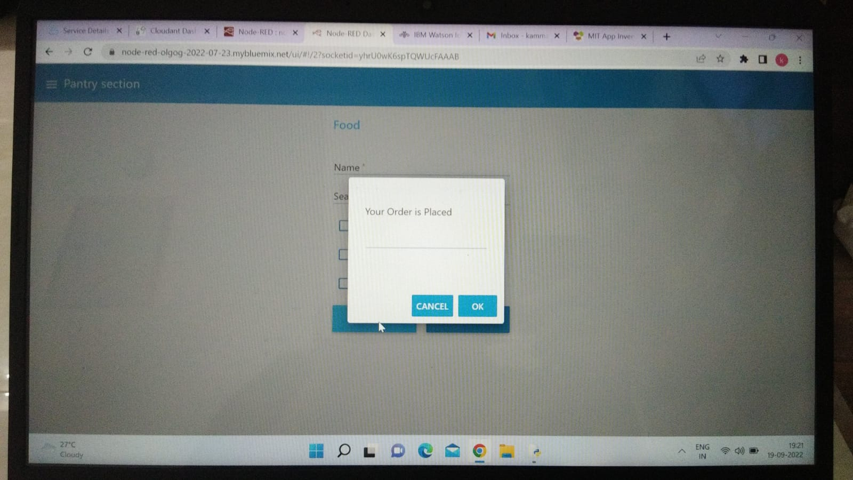

**Fig 37:** Node red dashboard

**MIT APP:**

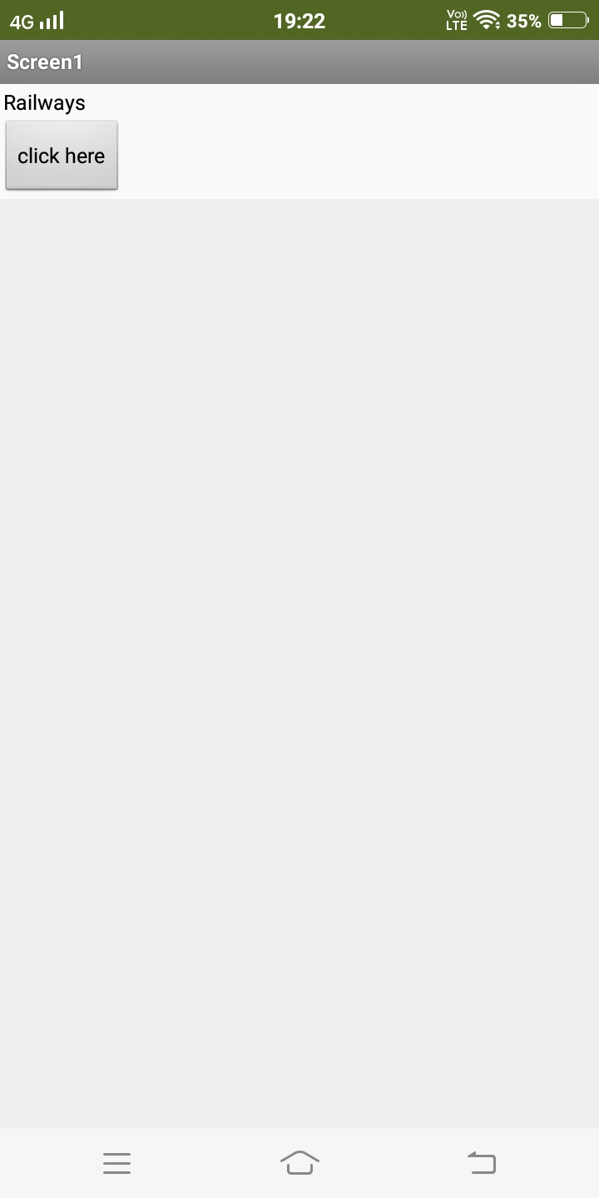

**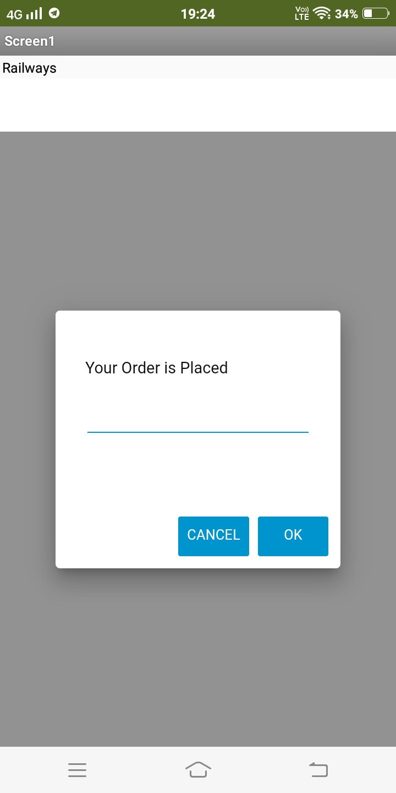  
 Fig 38:** MIT app UI

* The user can set a notification for intimating the train live status for both boarding and destination stations. There will a Mobile app for the public through which they can book tickets by seeing the available seats.

**CHAPTER 06**

**6.0 Conclusion**

In conclusion, I am well satisfied with my training. I have learned many new concepts, acquired a number of new technical skills and improved another group of existing skills. What I liked most about my training is that it is very strongly related to new emerging technology. This refutes the common saying that very little of the materials taught in university engineering courses is used by engineers working in the labor market. This dependency (relationship) is clearest in engineering design. I may count the technical skills that I learned or improved at the training site, other than those gained at college. At last, I hereby conclude that I have successfully completed my industrial training in Smart Bridge and gained knowledge.